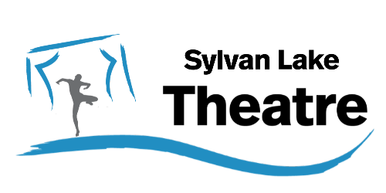
LIVE EVENTS! 2026-2027
- Theatre Trail 2026 Sept 12,13, 19, 20
Awarded Best Festival & Best Summer Event (2023-2026)
Auditions July 22. Check the website for info about Theatre Trail & Auditions
https://www.sylvanlaketheatre.com/about-theatre-tr...

- A Christmas Carol – Back by Demand
Sylvan Lake Theatre’s hit seasonal musical by Bridget Ryan will be presented in-
-Red Deer at Central Alberta Theatre’s Studio Theatre: Nov. 26-Dec. 6, 2026
-Sylvan Lake at HJ Cody High School: Dec 11-13
https://www.sylvanlaketheatre.com/a-christmas-carol

- Spring on Stage Play Festival
In association with Central Alberta Theatre and the Red Deer Players we announce a brand new one act play festival. Graduates of SLT’s Directors Bootcamp will showcase their plays, in this brand new One -Act Play Festival. Actors & theatre technicians contact Sylvan Lake Theatre for more information and ways to get involved.

LEARN! 2026-2027
For Actors, Playwrights, Directors and Youth
https://www.sylvanlaketheatre.com/learn
- CREATIVE KIDS Summer Programs
Youth summer drama camps for Ages 8-14
Acting, Improv, Devised Theatre, Voice & Speech, Performance

- DIRECTORS BOOTCAMP
2-month in-class learning for the most important role in the theatre- The Director
2-month casting/rehearsals/presentations creating the Spring On Stage Play Festival

Sylvan Lake Theatre Contact: Tanya Ryga, Artistic Director
Phone: 403-318-3180
Email: sylvanlaketheatre@gmail.com
Sylvan Lake, Alberta Canada
Website | Facebook | Instagram

