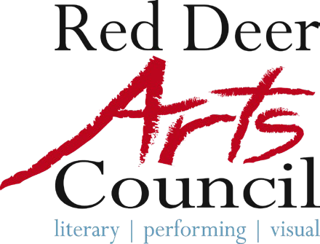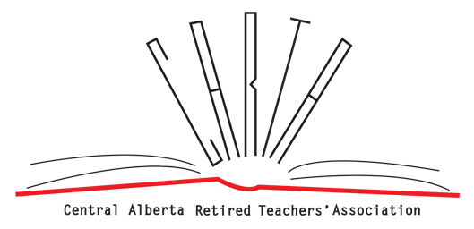
Call for Entry

“Threads that Connect US”
Red Deer Arts Council
Alberta Culture Days Event

September 2nd to October 3rd, 2026
Submission Deadline: 4:30 pm on August 16th, 2026

Open to visual and literary artists

Background
Each year, the Red Deer Arts Council and Central Alberta Retired Teachers’ Association partner to create events for local artists as part of Alberta Culture Days. For 2026, we’re excited to host the exhibition in our gallery and office space.

The Red Deer Arts Council’s community gallery's “Threads That Connect Us” exhibition will run throughout September. Be a part of Creative Red Deer and get involved!

Project
Artists can display their 2D, 3D and literary artworks as part of this exciting project in our street front community gallery. The timeline for the exhibition is during the full month of September 2026. Artists must reply by August 16th, 2026 with their submission.

The submission may include up to 3 images of the completed works for consideration (including poetry and written works), along with the requirements noted in this call. Works will be juried and only the works submitted may be displayed due to limited space. Should you require assistance with completing submission forms, please contact the office at 403-348-2787 for assistance.
Artists chosen will be notified by email by August 22nd, 2026. Art drop off date will be August 31st at 9:45am. The removal date for this exhibit is October 5th, 2026 at 9:30 am.

Visual art and literary works are welcome for this exhibition. Words and images inspire, blur, and blend between mediums and expectations in limitless creative possibilities. This is an innovative opportunity to showcase art of many genres in Red Deer and Central Alberta.
CARFAC artist fees for a group exhibition in other public spaces will be paid to each participating artist through Alberta Culture Days grant funding.

Timelines and Installation
- Exhibits are installed for the duration of September 2026.
- Art will be hung by volunteers under guidance by Red Deer Arts Council staff, please prepare for secure wall hanging. Plinths are available for display of 3D works.

More Details
- Any sales of displayed art must be delivered after the exhibition or picked up by the purchaser day of takedown.
- Access to space is coordinated through staff of the Red Deer Arts Council during work hours.
- Artists will ensure that exhibition content is appropriate for an all-ages public.
- Insurance of artwork is the responsibility of the artist. Neither the venue landlord, Central Alberta Retired Teachers Association, nor the Red Deer Arts Council accept liability for damage, theft, or loss beyond the minimum covered by our policy.
Submission

Submission Details and Criteria:
- This Juried Exhibition is an open call to artists in Central Alberta
- Submit images for no more than three of your 2D and/or 3D works. (Max 1MB each)
- information will be displayed with the art Only .jpeg/.jpg/.png image files will be accepted. Readable CD or USB sticks are accepted by mail/in person. Online cloud file folders are accepted but should not expire prior to August 30. (HEIC image files are incompatible with our computer systems.)
- Please label your image filenames with the Title of the Work, Media, Date, Value for sale, and Name of the Artist
- Number your images according to the listing in your completed Application & Declaration Form
- Complete, sign and submit the Application & Declaration Form (Page 5)
- Works should be completed within the last three years and should not have been seen by the public in Red Deer.
- All Submissions must be accompanied by a(n):
  - Artist Statement referring to the works submitted
  - Artist Biography
  - Curriculum Vitae (include your name in all files – i.e. Benny Goodman CV).
- No late or incomplete submissions will be accepted.
- Jurors will remain Anonymous, and the decisions made are final.
- Submission may be sent electronically, or a hard copy mailed/delivered to the office. Please contact the office at the number above prior to visiting in person.
Deadline for Entry: 4:30 pm, August 16, 2026
For more information, please contact:
Red Deer Arts Council Office Gallery
Bailey Horton
Bailey@reddeerartscouncil.ca

“Threads That Connect Us”
Juried Exhibition 2026
Application & Declaration Form

Name
Full Address
Phone
Email

Title of Work | Media and Date Produced | Size (W X H)  inches & feet | Value $
1.

2.

3.

- I hereby certify that this is my original artwork.
- I agree that the Red Deer Arts Council (RDAC) and supporting partners for the “Threads That Connect Us” Juried Exhibition will not be responsible for any copyright infringements, and I will release and indemnify them from any claims.
- I agree to abide by all rules and guidelines as provided to me by the RDAC and I agree that the RDAC is not responsible for NEGLIGENCE, LOSS, THEFT, ACTS OF ANY OTHER PERSON, or DAMAGE.
- Insurance is carried by the lender of the artwork.
- I grant my permission to be photographed or interviewed in connection with this exhibit.
- I grant my permission for my artwork to be photographed in connection with this exhibit.
- Entries must be submitted to the Red Deer Arts Council by August 16, 2026, by 4:30 pm.
- Note: Images submitted may be used for marketing and promotion only.

Signature or printed name
Date

Submit this application to either:
RDAC Office & Community Gallery: 6 – 4919 49 Street, Red Deer, AB T4N 1V1
Email: info@reddeerartscouncil.ca

