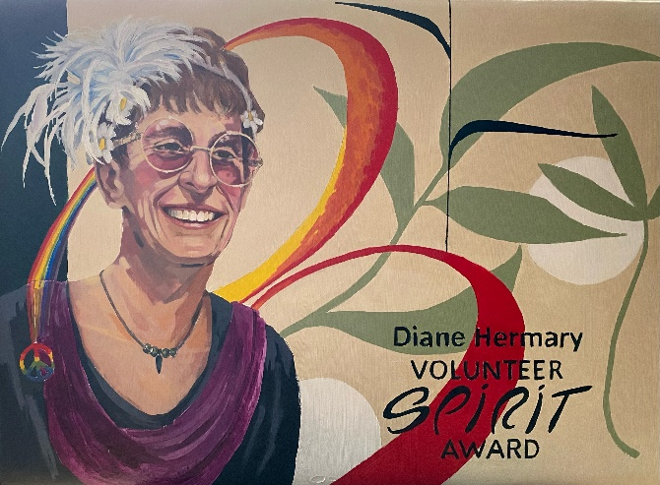

**Diane Hermary Volunteer Spirit Award**

**Part 1: Nominee Information**

*(PLEASE PRINT CLEARLY OR TYPE)*

First Name: __________________________________________________________________________

Last Name: __________________________________________________________________________

Mailing Address: (home) _______________________________________________________________

City/Town: ________________________ Province: _________ Postal Code: ______________________

Telephone (daytime): ______________________ E-mail: _____________________________________

The **Nominee** must sign and agree to the following:

*I have reviewed the nomination form and all attachments and agree to submit my name, contact information and details concerning my volunteer activities for the Red Deer Arts Council Volunteer Award Committee.*

Signed: _______________________________________ Date: _______________________________

Information gathered via this form will be shared only with the Red Deer Arts Council and its members to aid the Volunteer Award Committee for the purpose of determining a suitable award winner. The personal information on this form is collected under the authority of Section 33(c) of the Alberta Freedom of Information and Protection of Privacy Act and will be used solely for the purpose stated above. Questions regarding the collection or use of this information should be addressed to the Red Deer Arts Council.

**Part 2: Nominator Information**

*(PLEASE PRINT CLEARLY OR TYPE)*

First Name: __________________________________________________________________________

Last Name: __________________________________________________________________________

Position/Title: ________________________________________________________________________

Name of Charity Organization (any/all that are relevant): _____________________________________

____________________________________________________________________________________

Address: ____________________________________________________________________________

Telephone (daytime): _________________________ E-mail: __________________________________

The Nominator must sign and agree to the following:

*I have reviewed the nomination form and all attachments, and agree to submit my name, contact information and narrative justification to the Red Deer Arts Council Volunteer Award Committee.*

Signed: ____________________________________ Date: ____________________________________

Information gathered via this form will be shared only with the Red Deer Arts Council Volunteer Award committee for the purpose of determining a suitable award winner. The personal information on this form is collected under the authority of Section 33(c) of the Alberta Freedom of Information and Protection of Privacy Act and will be used solely for the purpose stated above. Questions regarding the collection or the use of this information should be addressed to the Red Deer Arts Council.

**Part 3: Narrative Justification for the Nominee**

The narrative justification must:

* state the nominee’s name and name(s) of the organizations in which the nominee has made their volunteer contributions,
* indicate approximately how many hours of volunteer service the nominee contributed in the past year OR how many years the nominee has provided active volunteer service,
* describe the nominee’s volunteer activity, including any special tasks or projects that have had a significant impact on the arts during the past year,
* provide additional background or contextual information about the nominee that may strengthen the award nomination.

**For additional information, please contact:**

Suzanne Hermary, Executive Director  
Red Deer Arts Council

6 – 4919 49 Street

Red Deer, AB T4N 1V1

403-3480-2787

info@reddeerartscouncil.ca