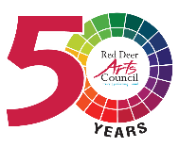
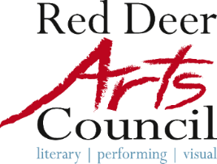
A vibrant community celebrating and supporting Arts, Culture, and Creativity!
Red Deer Arts Council & Red Deer Public Library are delighted to present

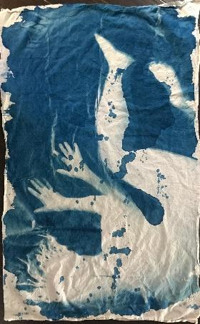
Transitions
Cyanotypes by Vivian Smith
running in the Kiwanis Gallery until February 9, 2025

#FirstFridaysRedDeer Opening reception: January 3 from 5:30 to 7:30 pm with the artist in attendance.

Description: In Vivian’s Artist Statement, she describes her latest body of work as follows “Transitions, positive and negative spaces work in tandem to repeatedly depict a body unsupported in space, caught in the act of moving from one location to another and without stable footing. The environment surrounding the bodies is ambiguous – it might be the ocean, a frozen lake, mist, the sky, in – utero, an x-ray, a blast zone etc. It is a space where a body once was. Major life events can leave us feeling unsettled and unmoored, floating in an undefined space. While this temporary state is disorienting, it also offers opportunities for transformation and growth, allowing us to gain knowledge and insight.”

Gallery Hours: Mon-Thurs 9am–8pm, Fri 9am–5pm, Sat & Sun 10am–3pm
Untitled
Cyanotype Dye
Vivian Smith, 2021

Red Deer Arts Council is pleased to present
Decades: Watercolours by Greg Swainson
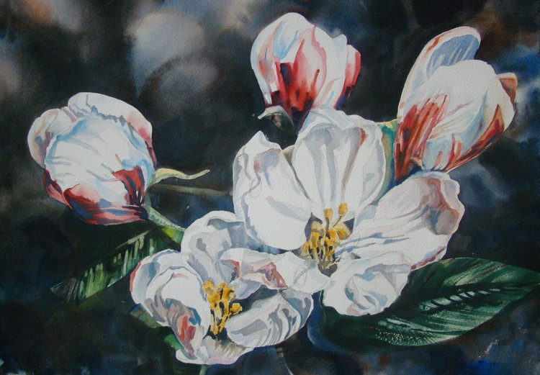
in the Red Deer Arts Council’s Community Gallery until January 6, 2025. Join us for #FirstFridaysRedDeer January 3 for a closing reception from 5 – 7pm. White Shadows
Watercolour
Community Gallery Hours: Mon to Fri 11am – 5pm Greg Swainson
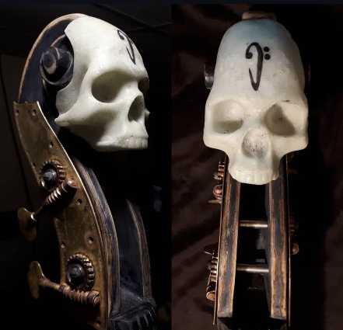

Next up, we’re featuring works by Ryan Boyd, a mixed media outsider artist with his first exhibition of works in 2D and 3D. Common items are reimagined and repurposed with a unique vision.




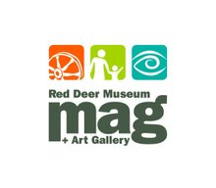




Creative Happenings in January 2025
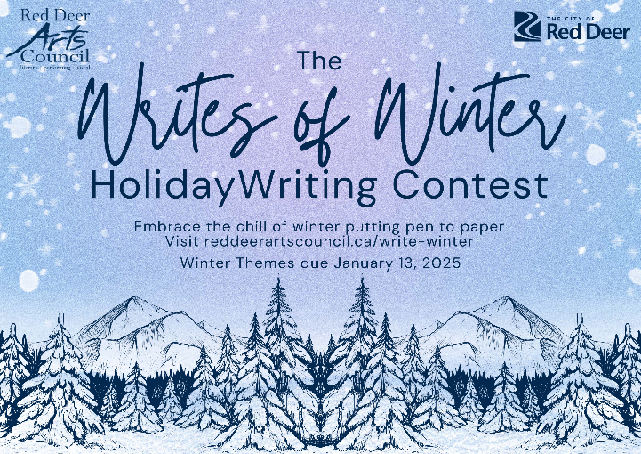
Submit your ‘Winter Chill’ themed stories to the Writes of Winter Contest!
Our Writes of Winter holiday story contest is still accepting submissions until January 13!
Submit your favourite short story (fiction), poem, or creative non-fiction tale up to 500 words in length for consideration in our Winter section to win great literary-inspired prizes. The winners of the Holiday section are posted on our website and WeAreRedDeer.ca! For full details and to read all submitted stories, visit RedDeerArtsCouncil.ca/write-winter!
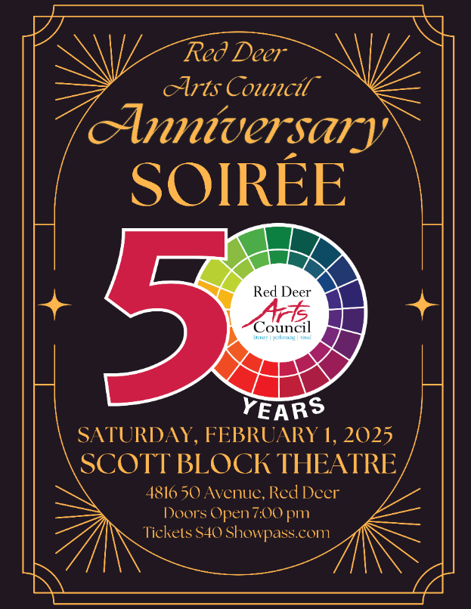
Anniversary Soirée Tickets on Sale
Escape the winter weather at the Scott Block Theatre on Saturday, February 1st starting at 7pm to celebrate our 50th anniversary supporting Arts & Culture in Central Alberta. With live painting, a big band sound, dancing, a pop-up art gallery & sale, poetry performances, song, and theatre, we can guarantee a great night out, just in time for Valentine’s Day! Wear your classy Blacks and Golds or stand out in brighter shades of your best! Be a part of this celebration event and kick off our next 50 years with a bang! 18+ Tickets $40 at Showpass.com/RDAC50anniv/
Updates from our 2024 Artwalk Developing Visual Artist Award Winner
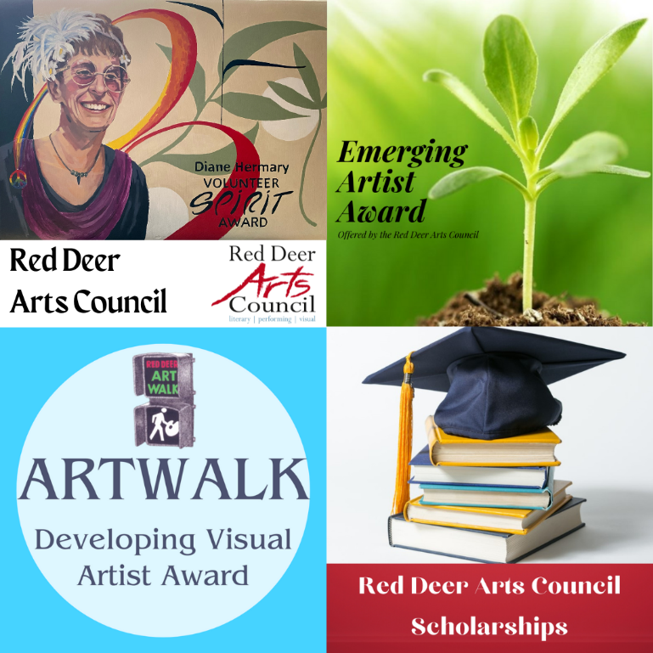
Being newer to Central Alberta, I was able to get my home studio walls and floor painted along with some heating which has been revolutionary. I started apprenticing as a tattoo artist at a shop in Lacombe and bought supplies for that – part of my plan to further support my practise. I still have money set aside to put towards further training opportunities, but family life and a few other detours have paused some of these undertakings. I’m working on an exhibition announcement in the new year, and grateful for the opportunity to develop my craft with the support I’ve received to me through earning this award. This honour from the community is helping me build a future in the arts that will further allow me to support my family.” Applications open January 6th and closes April 1st, 2025. Submit your application for consideration and win any of our 8 scholarships & awards!
Community Drum Circles! Join us! January 5th @The Flex, (5 – 4919 49 Street) from 2–4pm. Free to attend.
Brave New Words – This program will be paused in 2025 pending redevelopment.
Red Deer Arts Council Celebrates 50 years of Cultivating local Creativity
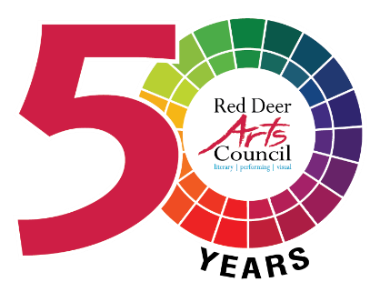
Inspiring, supporting and stimulating Red Deer’s arts and culture scene has been the Red Deer Arts Council’s mission for half a century.
On Feb. 1, local residents can celebrate that legacy at our 50th Anniversary Soiree.
Suzanne Hermary, Executive Director for the arts council, said the fundraising evening at the Scott Block will feature music, poetry reading, visual art, theatre, buffet “nibblies,” whiskey tasting and a cash bar.
“We are hoping you can join us and have some fun,” she added.
Although ‘arts centre’ was mentioned in various news articles going back to the late 1950s at the Red Deer Archives — (Hermary laughs that one was headlined “How to tolerate artists”) — the group that became the Red Deer Arts Council was started on Dec. 6, 1974.
Then known as the Red Deer and District Allied Arts Council, the non-profit was formed to help with the promotion, growth and evolution of the local arts scene. While this city has always benefitted from dozens of talented and dedicated creative individuals, it hasn’t always had a unifying voice to speak up for their needs, said Hermary.
In 2010, the allied arts council amalgamated with the Red Deer Cultural Charter Partners and CultureLink, and the three groups were re-branded as the Red Deer Arts Council. The arts council has been advocating for visual, performing and literary artists, and offering educational, promotional and networking opportunities. The idea is “to cultivate a creative culture,” to promote the value of arts in the community, and give younger artists the sense that it’s possible to make a career here.
Hermary noted arts and culture contributed $11 billion dollars annually to the provincial economy, as calculated by the Alberta Foundation for the Arts before the pandemic.
It permeates our everyday lives and provides jobs, including writers, technicians and actors in films and television. Hermary noted artists become entrepreneurs whenever they sell the things they create.
They also help create vibrant communities that attract new people and businesses; “Nobody wants to live in a place where there’s nothing to do,” she surmised.
Red Deer’s arts scene used to be more thriving. Hermary believes it’s still recovering from the pandemic, as well as the latest economic downturn and cancellations of the Red Deer Polytechnic’s theatre and music programs.
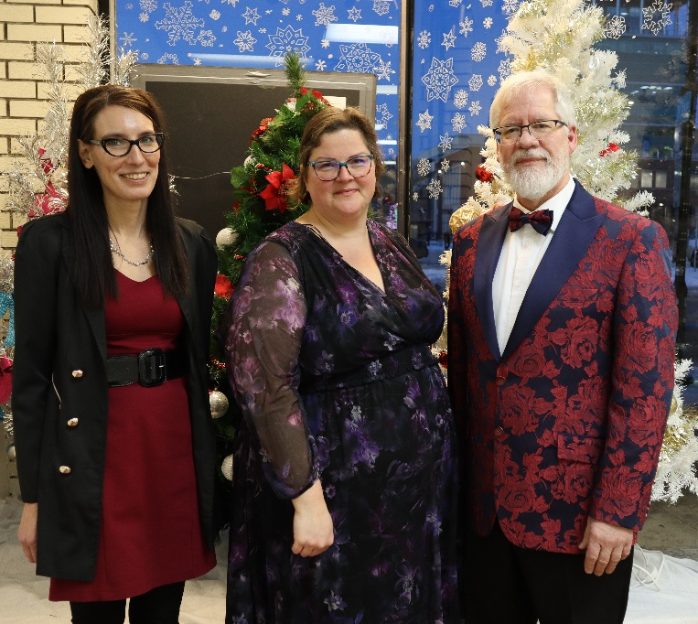
She’s saddened that RDP’s Arts Centre, as well as the downtown Welikoklad Centre are under-used because community groups can’t afford or access them. Hermary vows the arts council will continue to push for an accessible, affordable visual and performing arts centre for the community — as well as more learning opportunities so artistic students coming out of high school can continue their education in central Alberta.
She’s hearted by the high level of artistic training offered at local high schools, and the growing voice of the local arts community.
Hermary envisions a “Renaissance” of local arts and culture happening over the next few years, and hopes the City of Red Deer will help facilitate this by offering more operating grant opportunities to arts groups and by hiring more knowledgeable art and culture staff.
Tickets for the 7 p.m. 50th Anniversary Soiree are $40 and are available from the Red Deer Arts Council’s office or Showpass.com/rdac50anniv
RDAC Team members Kristina Miko, Suzanne Hermary, and Scott Barnabé get snazzy for a holiday 2024 photo shoot.

