
A dynamic community that celebrates and supports the Arts

Red Deer Arts Council and Red Deer Public Library

are excited to present

The 35th Middle Schools
Awesome Art Show!

running until May 29th, 2022
in the Red Deer Arts Council’s Kiwanis Gallery

First Friday Red Deer Opening
May 6th – 5:30 – 7:30 pm

Check out more details about our exhibitions and First Friday events around town via this link
https://www.reddeerartscouncil.ca/news/first-fridays/schedule
From TV shows to Celebrities to the world around them, Middle School students see the world with unique eyes. What will catch their eye this year? This annual exhibit delights its audience with a variety of works expressing these young students’ talents as they experiment with different subject matter and media. Come and meet the students and see what they see.
Featuring Students from:

Red Deer Arts Council

www.RedDeerArtsCouncil.ca | info@reddeerartscouncil.ca
403-348-2787 (ARTS)
6 – 4919 49 Street, Red Deer, AB T4N 1V1
 Red Deer Arts Council | @RDArtsCouncil
 RDArtsCouncil

Eastview, Central, West Park and Glendale Middle Schools
Library / Gallery Viewing Hours:
Mon – Thurs: 10 am – 8 pm
Fri: 12 pm – 5 pm
Sat: 10 am – 3 pm | Sun: Closed









Call for Entry for “Garden Works: Bud to Bloom”
Red Deer Arts Council - Visual & Literary Juried Art Exhibition
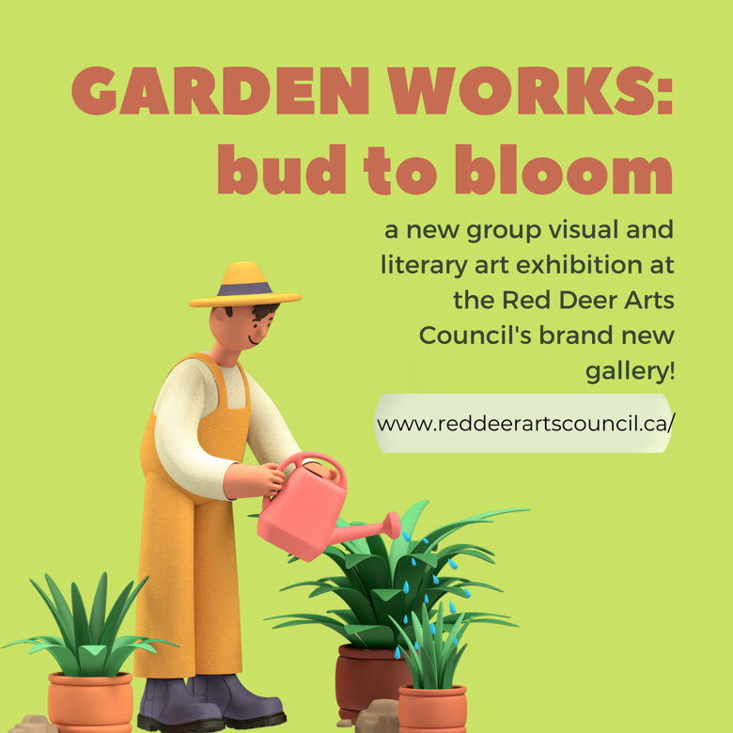
The Kiwanis Gallery in Red Deer is holding a juried exhibition, “Garden Works: Bud to Bloom” from July 4 to August 31, 2022. Entries must be submitted to the Red Deer Arts Council by 5pm, Tuesday, May 10, 2022.
Our Board and Staff are pleased to launch our brand-new art gallery space with this themed exhibition to celebrate Red Deer’s official Year of the Garden for 2022. We are excited to see the variety and different perspectives that our inclusive and diverse visual and literary artist community can share with us and those who appreciate arts and culture experiences in Central Alberta. Be a part of #CreativeRedDeer.
To help inspire you with how “Garden Works: Bud to Bloom” might be interpreted, we offer the following ideas for consideration, without limitation: Renewal, regrowth, regeneration, rebirth, replenishment, restoration, new beginnings, and abundance, harvest, and thanksgiving.
Gardens may be found in many forms: wild, impeccably groomed, vegetable, manicured, whimsical, meditative, romantic, and we invite you to depict our Canadian love of the great outdoors in our own backyards. The pandemic re-ignited our passion for gardens, and many found respite and creative expression in our gardens, and we hope that this year’s special distinction as the Year of the Garden will encourage you to plant some seeds of your own.
We encourage people of all ages, abilities, levels of experience, identities, and cultures to submit on our theme! Works of art celebrating the beauty of flowers, fruits, trees, vegetables, landscaping, horticulture, and gardens have a long and glorious past. Submission Deadline: 5:00 pm on Tuesday, May 10, 2022
Visit: https://www.reddeerartscouncil.ca/about-red-deer-arts-council/office-art to download the submission package!

You’re Invited! Provide Feedback and Guidance for Strategic Planning!
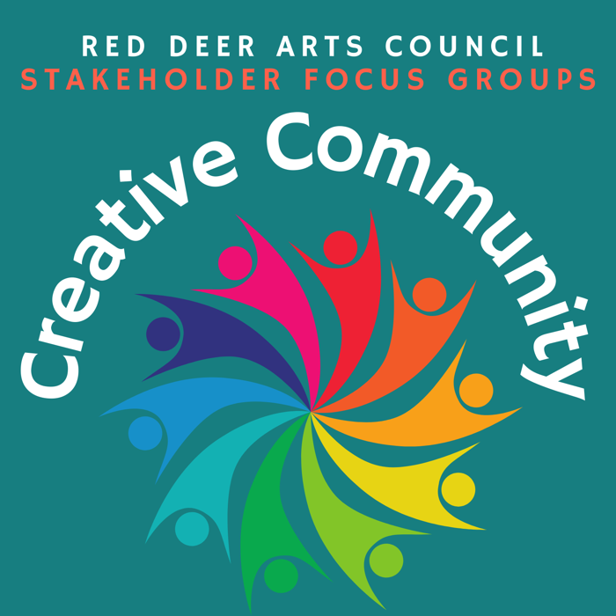
Since late November, the Board of the Red Deer Arts Council has been working on a new strategic plan for the organization and it’s time to hear from our members and the creative community at large. In the coming weeks, look for a personal invitation to attend one of our guided brainstorming session to consider that important aspects of the RDAC that you value, where you might see new opportunities and how we can better serve you as a local arts creator. Sessions are being generously led by facilitators from The City of Red Deer’s Community Development, Arts & Recreation department. If you’d like to join us, please contact Suzanne at reddeerartscouncil@gmail.com (after May 4th) to receive an invitation. We are excited to hear about your priorities, goals, needs, and see where we can complement community efforts to enhance our vibrant community through arts, culture & creativity programming and more!
Coming up soon: Our Scholarships & Awards Ceremony and the Grand Opening of the new office!
Kids in the Hall: Sports Hall of Fame is a surprisingly child-friendly destination
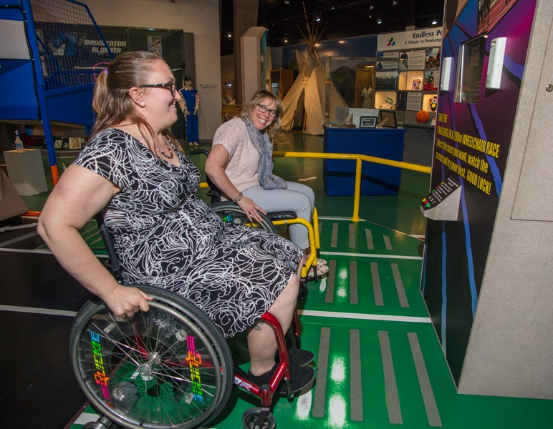
If you ask kids where they’d like to go for a fun day, “museum” isn’t usually the first word out of their mouths. But Tracey Kinsella and the staff of the Alberta Sports Hall of Fame and Museum are changing that.
“We’re not your typical museum,” says Kinsella, the executive director. Kids in the day programs or families who visit are in for some playing, touching, and learning. “You’re probably gonna sweat, if you’re doing it properly.”
She admits that the common view of a museum environment is that it’s “dusty and smelly and nothing new,” and unlikely to captivate a youngster. Even adults old enough to remember names like Kevin Lowe or Kevin Sirois often believe one visit is enough.
Executive Director Tracey Kinsella races Breanna Suk, coordinator of exhibits and collections, on the wheelchair race simulator at the Alberta Sports Hall of Fame and Museum.
“I’ve been there once,” is a common refrain, Kinsella says. What people don’t realize until they come back is how much is fresh and how much there is to do at the sports museum.
“We hear the shock and surprise” from recent visitors, she says.
The pandemic lockdown provided a “unique opportunity” for the facility, Kinsella explains. The museum normally closed only three days a year, but with many months in mothballs they had the chance to renovate. They built a birthday party room and a toddler area for new preschooler programming.
With more than 7,000 square feet, there’s room to shoot baskets, shoot pucks, play interactive games, and even race wheelchairs. As a sport institution, activity and fitness are central elements – even outside. A new exercise station is being set up this summer outside the entrance, and bikes and scooters are already available to rent, with immediate access to Red Deer’s trail system.
Of course, it is still a hall of sporting fame with a mandate to honour history. The major event every year is the October induction of 10 to 12 new Honoured Members. A fundraising golf tournament (assuming there are no further lockdowns) will also resume this September.
Information about those honoured members is newly available on interactive touchscreens in the Virtual Locker Room (also available on the website), with multiple search filters to help find the people, teams or sports you’re looking for.
Kinsella notes that kids looking for information about Connor McDavid or Johnny Gaudreau won’t find anything, since sports heroes aren’t eligible for the Hall until they’ve retired. But youths leave with an appreciation of sports and sport history, learning that lockdowns aren’t new in professional sports, or that an Alberta man holds the world record for longest baseball throw. Or that the Hall’s first female inductee, Annabelle McLean, was just 14 when her dad made her shoes so she could compete in track and field. She set records that stood for 60 years.
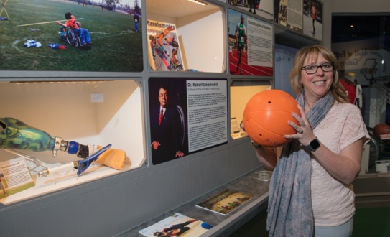
“We have literally thousands of those stories,” Kinsella says. Adults can of course still learn about the famous and familiar Albertans: Kurt Browning, Ken Read, the Sutter brothers or Jamie Salé. And for the artistically inclined, there’s an art gallery featuring artists specializing in sport. “Sports is another way to get creative,” says Kinsella.
For more information about the breadth of exhibits and programming at the Alberta Sports Hall of Fame and Museum, visit albertasportshall.ca or visit in-person by exiting Hwy 2 northbound, just north of the 32nd Street overpass.
Executive Director Tracey Kinsella jingles a goalball (used in the sport for visually impaired athletes) in the “para” exhibit at the ASHFM.

