**Red Deer Arts Council**

Emerging Artist Award

**Application Form**

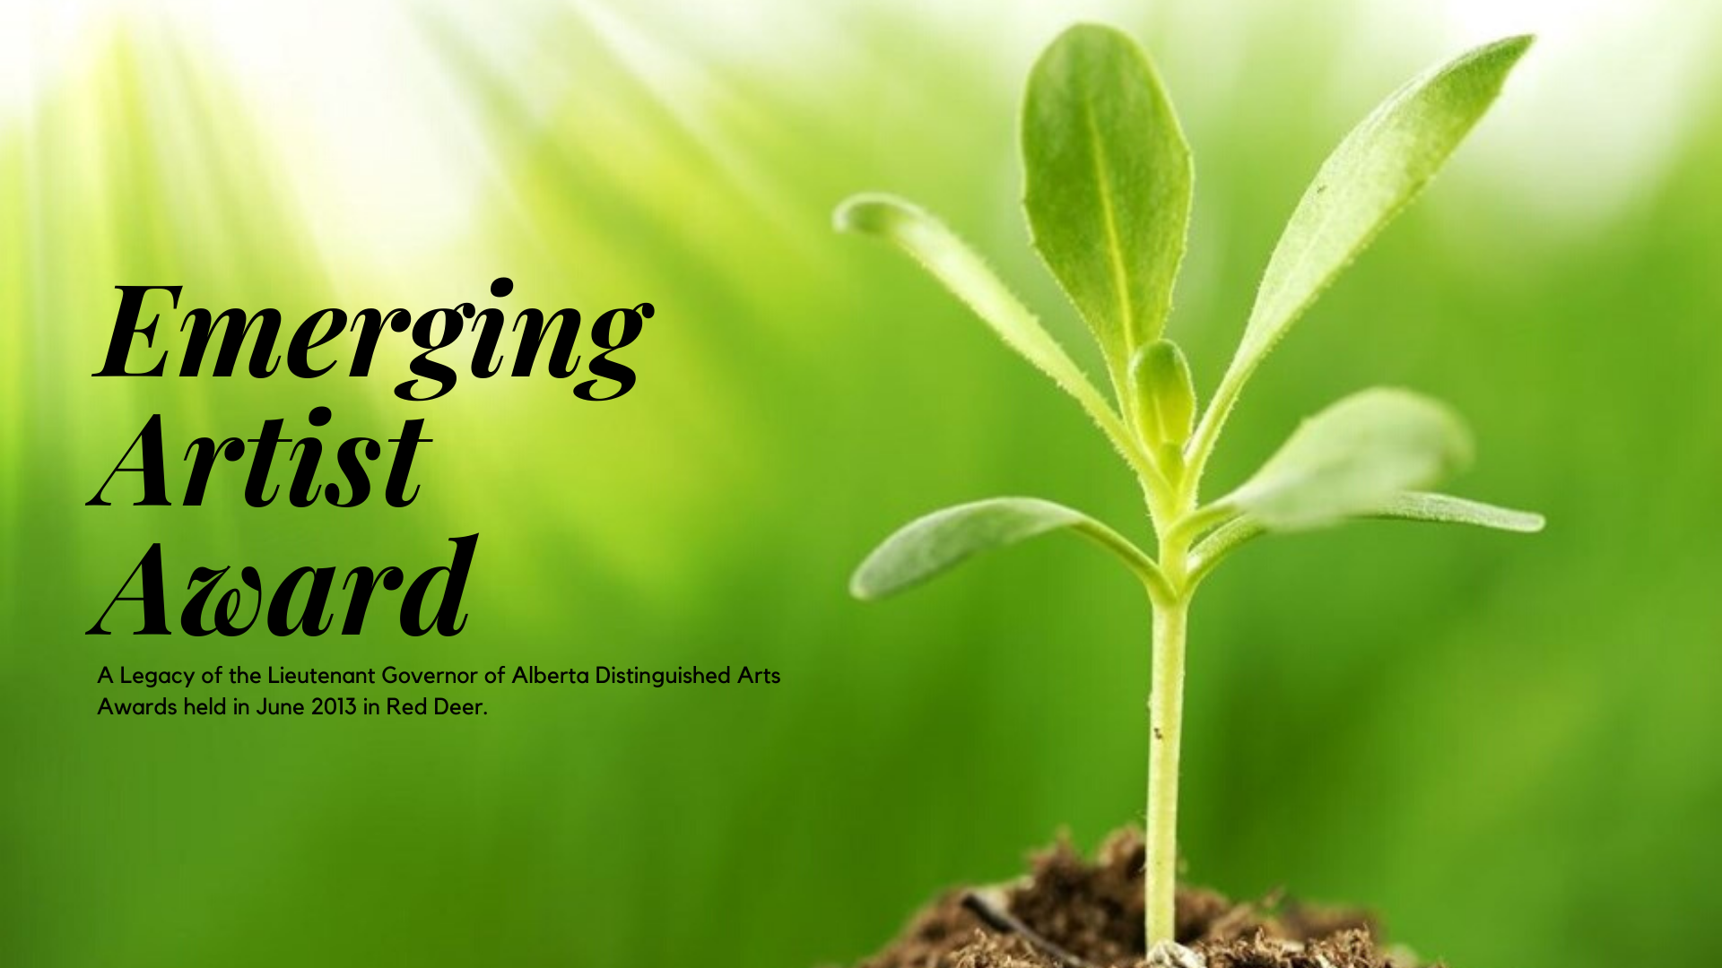

Assistance for Emerging Artists from Central Alberta

**Application Deadline: April 1st at 5:00 pm**

Submit the complete application and all supporting materials on or before the deadline to:

in person/mail: Emerging Artist Award

c/o Red Deer Arts Council

6 – 4919 49 Street

Red Deer, AB T4N 1V1

by email: info@reddeerartscouncil.ca

Please contact Suzanne Hermary, Executive Director, if you have questions about the award or the application process.

Telephone: 403-348-2787

Email: info@reddeerartscouncil.ca

**APPLICATION CHECKLIST**

**MY APPLICATION INCLUDES:**

* This completed checklist to ensure you submit a complete application (page 2)
* Emerging Artist Award Application Form (page 3)
* Applicant Declaration and Consent Form (page 4)
* Expert Appraiser Information Form (page 5)
* A cover letter including responses to the questions noted on page 3.
* A detailed, up-to-date professional artistic résumé or Curriculum Vitae (CV)
* Artist biography (max 500 words)
* Intended use of the funds
* Supporting documents for various genres:
* Literary: Writing samples, not more than 20 pages single-sided, double-spaced
* Visual: Up to 10 visual images with title, media, date produced. Submit clear images of your work – the images should be free of other subject matter and have appropriate lighting and colour quality or clear videos or legible literary works,
* Performing: Audio or video files with a combined viewing time of no more than ten minutes or relevant material (see tips at the end of this document.)
* Ensure that your submission is neat, labelled, easy to view and provides positive examples of your work,
* Do not include original works of art or one-of-a-kind support materials. Red Deer Arts Council is not responsible for loss or damage of application materials submitted,
* DVD, CD, USB, functioning direct web links* or a hard copy are acceptable formats for applications (files submitted electronically must be organized in a single folder),
* Images should be in JPEG (.jpg, .jpeg) format in RGB colour mode and be the original large size format or in appropriate materials depending on your artistic endeavour (e.g., video for singer/songwriter, filmmaker, etc.)

*\*The Red Deer Arts Council is not responsible for non-functioning web links preventing access to review submission materials. Any web links must land directly on the required page and not require a login or other entry to be viewed/played. \**

* Each page of my application & support materials is numbered and labelled with my name.
* All written materials are in black text, using a standard, easy-to-read font. No highlights or shaded areas, which make documents hard to read or photocopy.
* All pages are standard letter size 8 ½ x 11” paper.
* There are no staples, binders, or sleeves in the written portion of my application.

**We recommend you DO NOT ask the jury to look up materials relevant to your application, if they are important, provide them with your application.**

**Emerging Artist Award Application Form**

**=**

**Please complete form legibly**

|  |  |
| --- | --- |
| **Name of Applicant:** |  |
| **Mailing Address:** |  |
| **Email:** |  |
| **Phone:** |  |
| **Website:** |  |
| **Artistic Discipline(s):** |  |

**Please include a covering letter, providing the following information:**

1. **About you as an artist**

Briefly describe where you are in your artistic development. You might mention training experience, long-term goals, body of work to date, peer recognition, etc.

1. **Short-term artistic goals**
2. **What the award would mean to you**
3. **Intended Use of the Funds**

Identify how you plan to use the $1,000 award towards your continued development as an artist in your field?

**Emerging Artist Award Declaration and Consent**

**Declaration (You must meet all the criteria in the declaration to be considered and check off the required portions.)**

I declare that:

* I am a Canadian citizen or a permanent resident of two years of more.
* I have lived and practiced art in Red Deer or Central Alberta for two years or more.
* I have spent a significant and formative period of my artistic development in Alberta.
* I have the intent or desire to contribute to the artistic community of Red Deer and Central Alberta in the future.
* I agree to participate in a public event as determined by the Red Deer Arts Council.
* The statements herein and in all future submissions regarding this application are, to the best of my knowledge true and correct. I understand and accept the conditions of the award, as detailed in the guidelines. I agree to abide by the decision of the peer assessment jury.
* I understand that all or part of this application may be made available to the public in accordance with the Freedom of Information and Protection of Privacy Act.
* I declare that I owe no debts to the Red Deer Arts Council.

Signature: ______________________________________________________

**Privacy statement**

**Collection, use and disclosure of personal information**

This personal information is being collected in accordance with the *Freedom of Information and Protection of Privacy Act*, section 33(c), and is protected under the Act’s privacy provisions. Information submitted as part of the award nomination will be used to select award recipients, and excerpts may be presented during the award ceremony and subsequent publications and display. A list of award recipients will also be publicized.

* I consent to have my name published for any media/other use in conjunction with the Emerging Artist Award and
* I will be available to talk to the media when required.

Signature: ______________________________________________________

If you have any questions about the use of this information, contact the Red Deer Arts Council Executive Director, at Suite 6 – 4919 49 Street, Red Deer, Alberta, T4N 1V1

(403-348-2787.)

**Emerging Artist Award Appraiser Form Information**

**Identify Your Appraisers**

Identify two *experts* in a position to provide a candid assessment of your accomplishments and artistic potential. Appraisers cannot be related to you by birth or marriage and cannot be employed by you.

Please provide your appraiser with the appraisal form, available for download on our website. Appraisers must submit the completed form directly to the Red Deer Arts Council. The applicant is responsible for ensuring that the appraisal forms are received by the arts council prior to the April 1st deadline.

|  |  |
| --- | --- |
| **First Appraiser’s name:** |  |
| Area of expertise: |  |
| Position & institution if relevant: |  |
| Email: |  |
| Telephone: |  |

|  |  |
| --- | --- |
| **Second Appraiser’s name:** |  |
| Area of expertise: |  |
| Position & institution if relevant: |  |
| Email: |  |
| Telephone: |  |

**Support Materials for Submission**

Indicate which genre of the arts applies to you and include the submission material as described:

* **Literary Artists:**

Include no more than 20 pages of original writing in English, double-spaced and single-sided. Submit creative forms such as poetry, fiction, creative non-fiction, and/or children’s literature presented in an easily readable font size. Submit as a hard copy or in a standard Word, Google Docs, or PDF digital format. We are unable to accept Apple ‘Pages’ files.

* **Visual Artists:**

Include a USB key or cloud folder link* with 9 to 18 digital images of individual artwork, at least two-thirds of which were completed within the last year. Ensure that all file names are clearly identified/named and include a corresponding list using the below format indicating Title, Media, Date, and Size (W x H x D in inches/feet.)

Include an artist statement for at least ONE of the works in the portfolio. Do not send actual artworks, they will not be returned. You may copy and type directly into the below chart.

|  |  |  |  |  |
| --- | --- | --- | --- | --- |
| # | TITLE | MEDIUM | YEAR | DIMENSIONS |
| **1** | Click here to enter text. | Click here to enter text. | Click here to enter text. | Click here to enter text. |
| **2** | Click here to enter text. | Click here to enter text. | Click here to enter text. | Click here to enter text. |

* **Performing and Cinematic Artists:**

Submission may include a CD, DVD, website links (where your video is hosted), cloud folder links, or a USB key with 2 or 3 samples of the candidate’s choice in performance, one of which must be solo. Total duration of all content should not exceed 10 minutes. *Please see the Tips for Performing Artists on page 7 of this document.*

*\*The Red Deer Arts Council is not responsible for non-functional web links preventing access to review the submission materials. Any web links must land directly on the required page and not require a login or other entry to be viewed/played. Materials that cannot be accessed will not be considered. \**

**Provide all materials relevant to your application, if they are important, DO NOT ask the jury to look them up, please include them. Additional supporting documents are a good thing.**