**First Fridays Gallery Openings for Red Deer   
September 5th, 2025**

Visit the interactive Gallery Guide with map and listings at:

<https://www.reddeer.ca/recreation-and-culture/arts-and-culture/art-galleries/gallery-guide/>

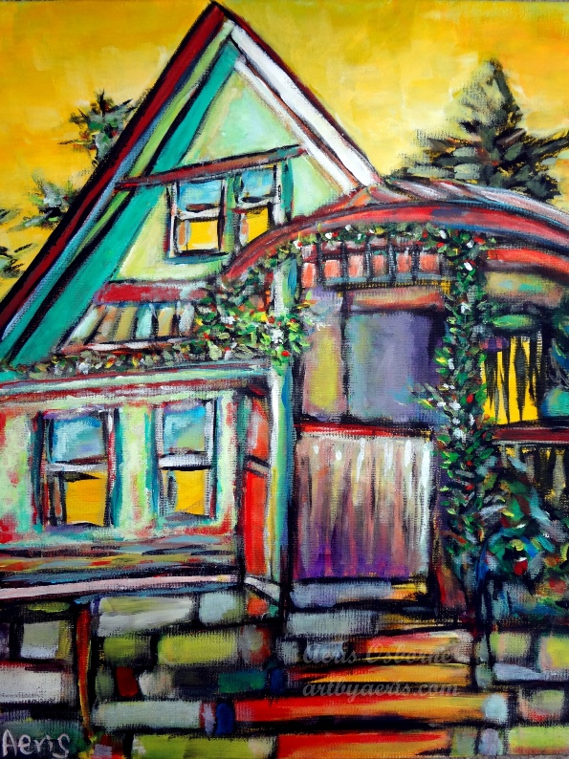***“Colourful Travel Journey”***

**Artist:** Aeris Osborne

**Media:** Acrylic paintings

***Kiwanis Public Art Gallery***, Red Deer Public Library – Downtown Branch, 4818 49 Street

**Exhibition Dates:** August 18th – October 6th, 2025

**#FirstFridaysRedDeer**

First Fridays Red Deer Opening: September 5th, 2025, from 5:30 to 7:30 pm.

Red Deer Arts Council and Red Deer Public Library are pleased to present, “***Colourful Travel Journey”*** artworks by Aeris Osborne running from August 18th to October 6th, 2025, in the Kiwanis Gallery.

Using her travels through the Rocky Mountains to British Columbia, Aeris is a self-taught Hong Kong-born, Alberta-based Edmonton visual artist, the 3rd Alberta Artist in Residence/Art Ambassador appointed by the Government of Alberta and has been painting for over thirteen years. Aeris loves  
exploring our Canadian landscape, especially her travel journeys that helped boost her imagination as a form of self-exploration and an opportunity to connect with nature. She hopes that her passion for a modern Impressionist art form will cheer people up with hope and light.

*Café In Revelstoke*

*Acrylic*

*Aeris Osborne*

Aeris Osborne is a Hong Kong–born Canadian visual artist based in Edmonton, Alberta. She has lived in Alberta since 2007 and has been painting for over 16 years. A self-taught painter and registered social worker, Aeris combines her social work background with her art to explore cultural, heritage preservation, and community storytelling through colorful, bold impressionist interpretations of architecture and landscapes.

In 2022, Aeris was appointed Alberta Artist in Residence (AIR) / Arts Ambassador by the Government of Alberta—becoming the third artist, the first immigrant, and the first self-taught artist to receive this provincial title since the program’s inception in 2019. For her AIR project, Alberta Old Buildings, she traveled over 3,000 km across Alberta, visiting more than 30 museums and heritage sites. The resulting exhibition toured Edmonton, Calgary, and Red Deer, receiving coverage from 13 media outlets across Alberta and Vancouver. This project integrated Augmented Reality (AR) technology into her paintings, enabling audiences to interact with the works via smartphone and explore the history of each building in an immersive, contemporary way.

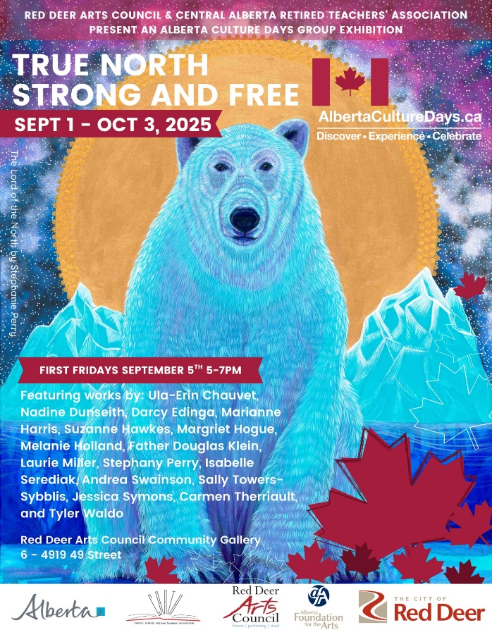 ***‘True North Strong and Free’ 2025 Alberta Culture Days Exhibition***

Media: 2D, 3D and literary artworks  
**The Red Deer Arts Council Community Gallery**, Suite 6–4919 49 Street  
**Exhibition Dates:** September 1st – October 3rd, 2025  
**#FirstFridaysRedDeer** September 5th, 2025, from 5:00 – 7:00pm

**A Celebration of Creativity of Alberta Artists | Alberta Culture Days 2025**  
Presented by the **Red Deer Arts Council** & the **Central Alberta Retired Teachers’ Association**

What does *“True North Strong and Free”* mean to you?  
This vibrant exhibition invites you to explore the powerful, personal, and poetic expressions of Central Alberta artists through 2D, 3D, and literary artworks.

*The Lord of the North*

*Acrylic on Canvas*

*Stephanie Perry*

From paint to poetry, sculpture to story—this dynamic juried show blends words and visuals, tradition and innovation. It’s an inspiring look at how local artists interpret identity, place, and freedom in uniquely Canadian ways.

Be part of Creative Red Deer.  
Show your pride. Your passion. Your perspective.  
Experience ‘True North Strong and Free.’

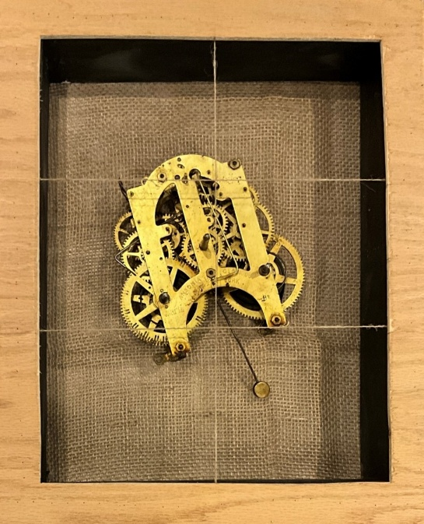***The Long Night of Unweaving***

Artist: Glynis Wilson Boultbee

Media: Mixed Media

***Viewpoint Gallery***, City of Red Deer Culture Services (Central Intermediate School,) 5205 48 Avenue

**Dates:** September 5 – October 23, 2025

First Fridays:

**Reception:** September 5 – Artist Tour & Poetry Reading 6pm

* October 3 – Artist Tour & Poetry Reading 6pm

**FREE Alberta Culture Days Workshop:**

* September 11 – Tapping the Well: Playful Writing Prompts for the Imagination 6:30-8:30pm

*Photo credit: The Archaeology of Grief Series (Movement), found objects and burlap, Glynis Wilson Boultbee, 2024*

* Click here to book:

<https://looknbook.reddeer.ca/RedDeer/public/booking/CourseDetails/38812>

**#FirstFridaysRedDeer**

**The Long Night of Unweaving**

This exhibit of sculptural work, photographs, and poetry traces the artist’s journey through the loss of both her parents during Covid times. It includes reflections on the immediate aftermath of these losses, the sifting and sorting of their belongings, and the time when she began to emerge from intense grief into a world that was the same as it ever was and changed forever. Tender, heartfelt, and hopeful, this exhibit invites viewers to reflect on how we make sense during times of personal difficulty, and it celebrates the power of the arts to offer healing.

**Glynis Wilson Boultbee**

Glynis Wilson Boultbee has built her life and work around creativity, the arts, and community. She focused on writing for many years before enrolling in the Red Deer Polytechnic Visual Art program. Glynis combines text (mostly poetry) and visual art to create multi-disciplinary installations that explore the stories of our lives. Sculpture and mixed media are her favourite visual practices. She relishes using repurposed materials and found objects. The bandsaw is her particular friend.

***Ian Cook: A Retrospective***

***Location:******Red Deer Museum + Art Gallery (MAG),****4525 47A Avenue*

***Artist:*** *Ian Cook****Medium:*** *Bronze Sculptures  
Dates: September 6th – November 22nd ,2025****#FirstFridaysRedDeer******OPENING RECEPTION: September 5th | 5-8pm***

You are invited! In September, the MAG’s #FirstFridaysRedDeer evening will offer a first-look at [*Ian Cook: A Retrospective*.](https://reddeermuseum.com/ian-cook-a-retrospective/)

*Artist Ian Cook is the founder of Red Deer Polytechnic’s (RDP) highly successful Visual Arts Program as well as the initiator of the RDP Permanent Art Collection, Summer Series Program, and the Bronze Casting Foundry. Undoubtedly Ian’s 50-year career as an Arts Educator has created a legacy through his profound influence on emerging and aspiring artists in Alberta.*

*Ian Cook, Tornado Vortex 2 (2024), Patinated Cast Bronze*

*This exhibit highlights and introduces us to Ian’s art practice as a sculptor working in bronze. The work in the exhibition spans from 1980, the year the foundry was established, to the present day.*

*While landscape is an important contextual element in Ian’s work, his sculptures include a reference to a human presence and imprint on the landscape in the form of constructs such as fences, dolmen, temples, houses, bridges, airfoils, and vessels. Also important within his work is the reference to the classical elements of Air, Earth, Water and Fire, and the dynamics of weather on the earth and structures within the landscape.*

*The most recent sculptures are his Tornado Series which respond to the current crisis of global warming and climate change. These sculptures present to the viewer a series of severe weather events which raise philosophical questions about being, time, and place.*

***Under the Influence… Ian Cook: selected works of RDP Permanent Art Collection***

September 6 – November 29, 2025

You are invited! In September, the MAG’s #FirstFridaysRedDeer evening will also offer a first-look at gallery 2 exhibit [*Under the Influence…*](https://reddeermuseum.com/under-the-influence/)

*The Red Deer Polytechnic Permanent Art Collection was started by former Instructor Ian Cook, with the idea that students should see important works beyond photographic slides and visual aids. Ian helped to collect, donate and grow original works by Canadian and International masters. This exhibition will feature the works that were collected by or Under the Influence of Ian during his time at RDP.*

On this special First Friday at the MAG, we’re not just celebrating these 2 exhibit openings… we are also [getting creative](https://reddeermuseum.com/events/open-studio-31/) (in the SDS) in the style of featured artist, Ian Cook.

*\*In celebration of*[*Alberta Culture Days*](https://www.alberta.ca/alberta-culture-days)*, and thanks to funding from the Government of Alberta, all programs are****free to attend****for the month of September!*

*"****Light and Shadow"***

***Location:******Alchemy Art Loft Gallery Unit 116, 5301, 43 Street, Red Deer, Alberta T4N 1C8, Canada***

***Artist(s)****:*Various Local***Mediums:*** *2D and 3D  
Dates: August1st-September 30st, 2025*

***#FirstFridaysRedDeer******Description:*** LIGHT & SHADOW: A thematic focus on contrasts, chiaroscuro, and the interplay of light and darkness.Live performance by Quora Strings, Refreshments served.

***Art Attack for Teens***

***Artist(s):*** *Various*

***Media:*** *2D artworks*

*The Corridor Community Gallery, 4501 47A Ave, inside the Recreation Centre*

***Dates:*** *July 30th – September 25th, 2025*

***#FirstFridaysRedDeer***

***Description:*** Teen Art Attack is a weeklong visual arts intensive for teens age 13-17 hosted by The City of Red Deer at the downtown Culture Services building. Over five days, teens experiment with art materials, techniques, and concepts – both contemporary and historical.

*Red Flowers*

*Acrylic*

*Ever C./H.*

Guided by practicing Artists, campers explore acrylic painting, printmaking, sculpture and mixed media. Each piece is the result of hands-on exploration, risk-taking and personal growth. Beyond technique, these artworks reflect the voices of a new generation: bold, thoughtful, and unapologetically free-spirited.

At the end of the action-packed week, the students and their instructor put together a showcase of works to be displayed in a real gallery setting – getting a taste of what it’s like to create with the intention of sharing their art.

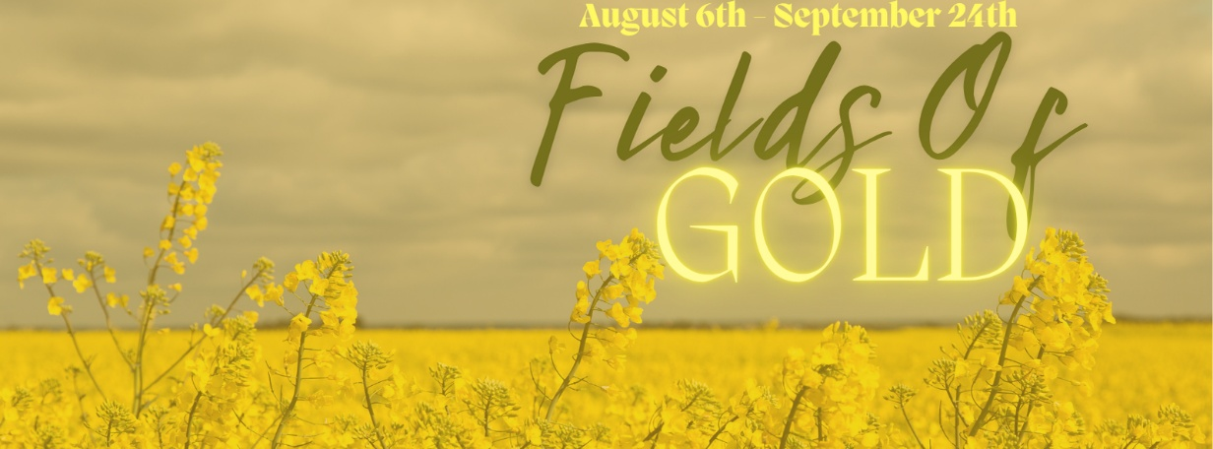

***“Fields Of Gold”***

***Artist(s):*** *Margaret Blank, Larry Reese, Kelvin Christensen, and Many More.*

***Media:*** *Various Mediums*

***Curiosity Art & Framing****, 5002 48 Street, Red Deer*

***Dates:*** *August 6th – September 24th, 2025*

***#FirstFridaysRedDeer***

***Description:*** August to September the fields glow with gold as harvest season comes ever closer. From wheat, to canola these golden fields are a staple of Alberta. Come and celebrate our province's harvest season with these harvest themed pieces in Curiosity Art & Framing latest exhibit, "Fields of Gold"!

***Artribute Art School***, 212 – 4836 50 Street, in the Old Courthouse. Treaty 6 & 7

***Art in the Hallway***, Northside Community Centre YMCA, 6391 76 Street

***Lacombe Memorial Centre*** 5214 – 50 Ave, Lacombe, AB

***Lacombe Performing Arts Centre****, 5227 Calgary Edmonton Trail, Lacombe, AB*

***Solorzano Spa Cafe & Wine Bar****, 4631 50 Street, Red Deer*

***The Corridor Community Gallery***, 4501 47A Ave, inside the Recreation Centre

***The Majorie Wood Gallery****, 6300 45Avenue Kerry Wood Nature Centre*

***The White Gallery***, downstairs from Sunworks Living, 4913 50 Ave, Red Deer, AB

~~~

