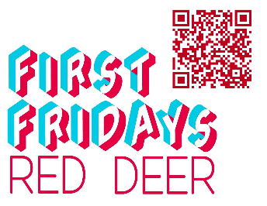
First Fridays Gallery Openings for Red Deer
October 3rd, 2025

Visit the interactive Gallery Guide with map and listings at:
https://www.reddeer.ca/recreation-and-culture/arts-and-culture/art-galleries/gallery-guide/

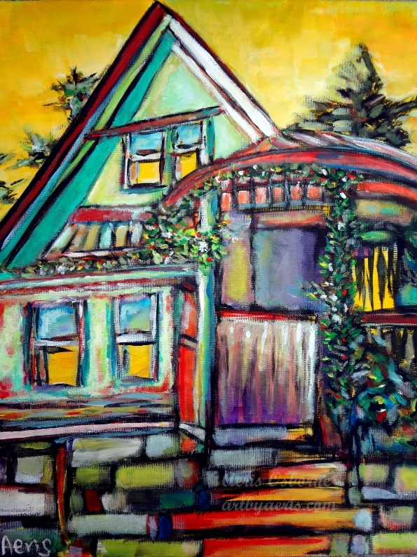
“Colourful Travel Journey”
Artist: Aeris Osborne
Media: Acrylic paintings
Kiwanis Public Art Gallery, Red Deer Public Library – Downtown Branch, 4818 49 Street
Exhibition Dates: August 18th – October 6th, 2025
#FirstFridaysRedDeer
First Fridays Red Deer Opening: October 3rd, 2025, from 5:30 to 7:30 pm.
Red Deer Arts Council and Red Deer Public Library are pleased to present, “Colourful Travel Journey” artworks by Aeris Osborne running from August 18th to October 6th, 2025, in the Kiwanis Gallery.

Using her travels through the Rocky Mountains to British Columbia, Aeris is a self-taught Hong Kong-born, Alberta-based Edmonton visual artist, the 3rd Alberta Artist in Residence/Art Ambassador appointed by the Government of Alberta and has been painting for over thirteen years. Aeris loves exploring our Canadian landscape, especially her travel journeys that helped boost her imagination as a form of self-exploration and an opportunity to connect with nature. She hopes that her passion for a modern Impressionist art form will cheer people up with hope and light.
Café In Revelstoke
Acrylic
Aeris Osborne

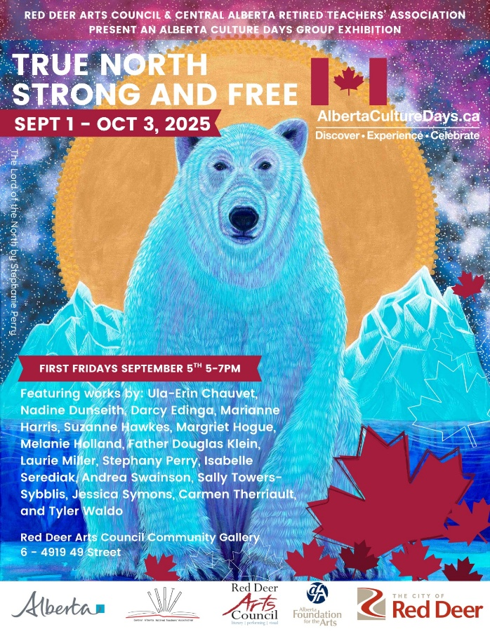
‘True North Strong and Free’ 2025 Alberta Culture Days Exhibition
Media: 2D, 3D and literary artworks
The Red Deer Arts Council Community Gallery, Suite 6–4919 49 Street
Exhibition Dates: September 1st – October 3rd, 2025
#FirstFridaysRedDeer October 3rd, 2025, from 5:00 – 7:00pm
A Celebration of Creativity of Alberta Artists | Alberta Culture Days 2025
Presented by the Red Deer Arts Council & the Central Alberta Retired Teachers’ Association
What does “True North Strong and Free” mean to you?
This vibrant exhibition invites you to explore the powerful, personal, and poetic expressions of Central Alberta artists through 2D, 3D, and literary artworks. From paint to poetry, sculpture to story—this dynamic juried show blends words and visuals, tradition and innovation. It’s an inspiring look at how local artists interpret identity, place, and freedom in uniquely Canadian ways.
The Lord of the North
Acrylic on Canvas
Stephanie Perry
Be part of Creative Red Deer.
Show your pride. Your passion. Your perspective.
Experience ‘True North Strong and Free.’

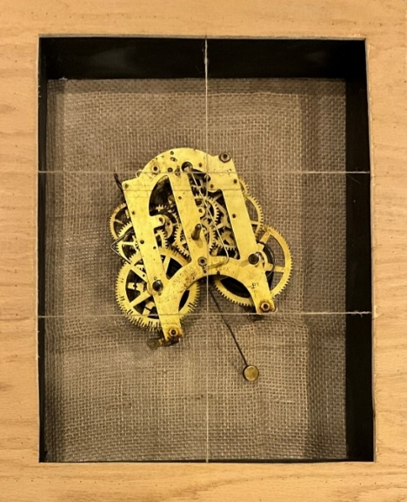
The Long Night of Unweaving
Artist: Glynis Wilson Boultbee
Media: Mixed Media
Viewpoint Gallery, City of Red Deer Culture Services (Central Intermediate School,) 5205 48 Avenue
Dates: September 5 – October 23, 2025
First Fridays:
Reception: October 3 – Artist Tour & Poetry Reading 6pm
#FirstFridaysRedDeer

The Long Night of Unweaving
This exhibit of sculptural work, photographs, and poetry traces the artist’s journey through the loss of both her parents during Covid times. It includes reflections on the immediate aftermath of these losses, the sifting and sorting of their belongings, and the time when she began to emerge from intense grief into a world that was the same as it ever was and changed forever. Tender, heartfelt, and hopeful, this exhibit invites viewers to reflect on how we make sense during times of personal difficulty, and it celebrates the power of the arts to offer healing.
Photo credit: The Archaeology of Grief Series (Movement), found objects and burlap, Glynis Wilson Boultbee, 2024

Glynis Wilson Boultbee
Glynis Wilson Boultbee has built her life and work around creativity, the arts, and community. She focused on writing for many years before enrolling in the Red Deer Polytechnic Visual Art program. Glynis combines text (mostly poetry) and visual art to create multi-disciplinary installations that explore the stories of our lives. Sculpture and mixed media are her favourite visual practices. She relishes using repurposed materials and found objects. The bandsaw is her particular friend.

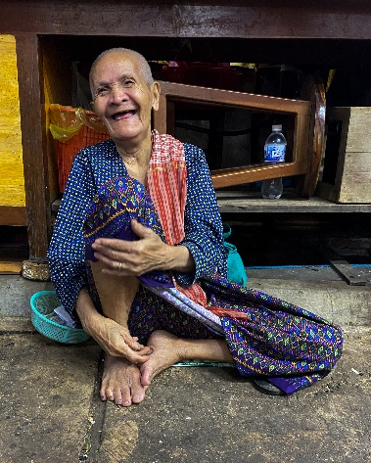
Winning Competition Photos from the Central Alberta Photographic Society
Artist(s): Various
Media: 2D Photographs
The Corridor Community Gallery, 4501 47A Ave, inside the Recreation Centre
Dates: October 2, 2025 – January 2, 2026
#FirstFridaysRedDeer
Description: These images represent award-winning entries from our Winter 2024 and Spring 2025 Members’ Photography Competition. Submissions were received across nine categories, each designed to recognize a wide range of photographic styles and subjects. Winning photographs were selected by a panel for their visual impact and technical proficiency. Collectively, these works exemplify the high standard of excellence achieved by our members.
“Joy” photograph
Helen Dobson

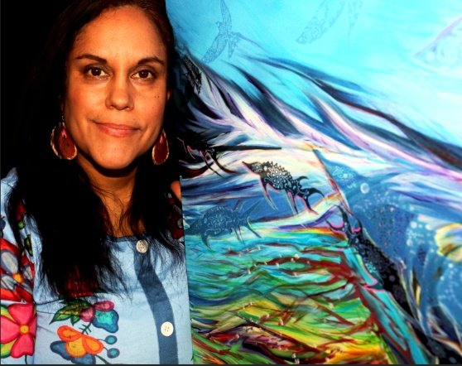
Artworks by Crystal Lee Clark
Location: Art in the Hallway, Northside Community Centre YMCA, 6391 76 Street
Artist: Crystal Lee Clark
Media: Painting, Mixed Media and Digital Art
Dates: October 1st – October 31st, 2025
No First Fridays. Gallery Open from Monday-Friday 8:15am until 9pm
Description: Crystal Lee Clark is a Dene-Cree-Métis artist and educator from Fort McMurray, Alberta, now based in Central Alberta. Her multidisciplinary practice blends painting, mixed media, digital and public art to honour Indigenous knowledge, land-based teachings, and community narratives. Rooted in water, plant, and animal stories, her work reflects interconnectedness and flourishing. With over 20 years as an Indigenous educator and consultant, she also weaves reconciliation, history, and identity into her art, creating works that teach as they inspire. Her pieces can be found in Fort McMurray, Edmonton, Calgary, Vancouver, and across community spaces, where she continues to uplift Indigenous voices and bring people together in a good way.
Crystalleeclarkartist.ca
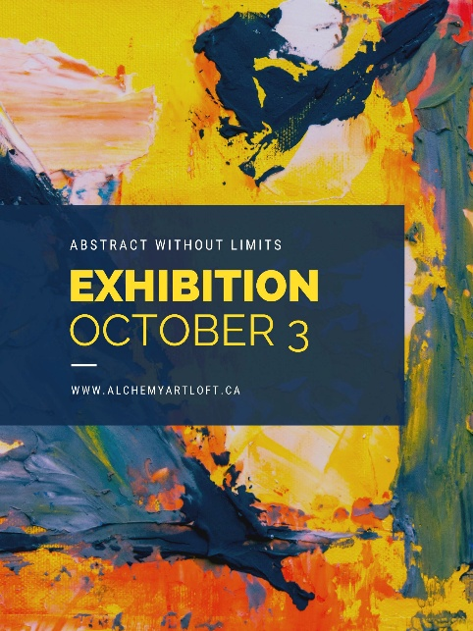

"Abstract Without Limits"
Location: Alchemy Art Loft Gallery Unit 116, 5301, 43 Street, Red Deer, Alberta T4N 1C8, Canada
Artist(s):Various Local
Mediums: 2D and 3D
Dates: October 3rd- November 30th, 2025
#FirstFridaysRedDeer
Opening Night October 3rd 6:00 PM – 9:00 PM
Description: Step into a world of color, form, and imagination with our newest exhibition: Abstract Without Limits.

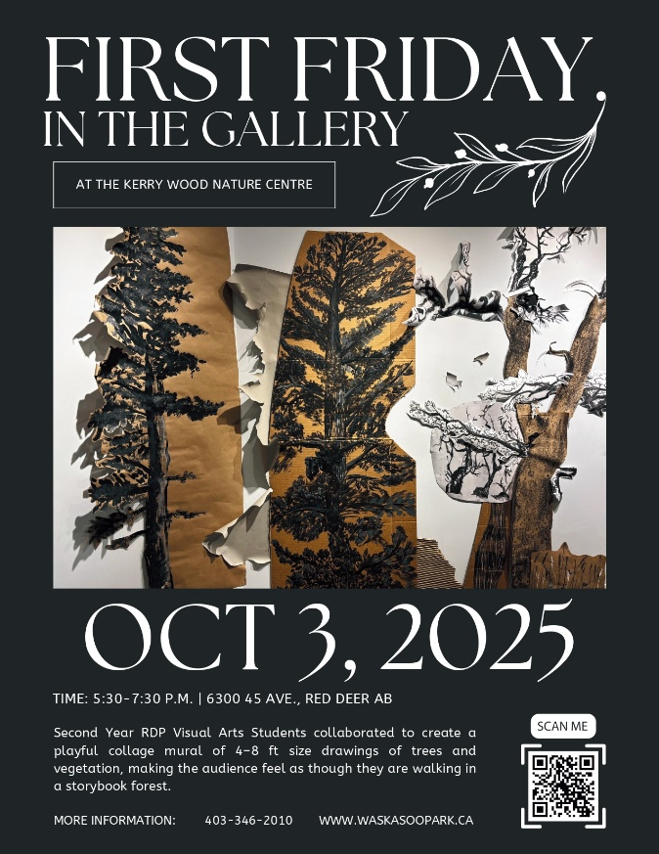

"RDP Visual Arts Collage Mural"
Location: The Majorie Wood Gallery, 6300 45Avenue Kerry Wood Nature Centre
Artists: Visual Arts Student Red Deer Polytechnic
#FirstFridaysRedDeer
October 3rd, 2025
Time: 5:30pm-7:30pm
Description: Second Year RDP Visual Arts Students collaborated to create a playful collage mural of 4-8ft size drawings of trees and vegetation, making the audience feel as though they are walking in a storybook forest.

Ian Cook: A Retrospective
Location: Red Deer Museum + Art Gallery (MAG), 4525 47A Avenue
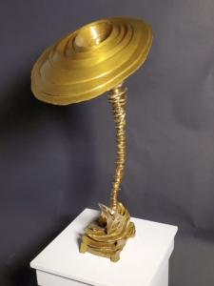
Artist: Ian Cook
Medium: Bronze Sculptures
Dates: September 6th – November 22nd ,2025
#FirstFridaysRedDeer
October 3rd, 2025

Artist Ian Cook is the founder of Red Deer Polytechnic’s (RDP) highly successful Visual Arts Program as well as the initiator of the RDP Permanent Art Collection, Summer Series Program, and the Bronze Casting Foundry. Undoubtedly Ian’s 50-year career as an Arts Educator has created a legacy through his profound influence on emerging and aspiring artists in Alberta.
This exhibit highlights and introduces us to Ian’s art practice as a sculptor working in bronze. The work in the exhibition spans from 1980, the year the foundry was established, to the present day.
Ian Cook, Tornado Vortex 2 (2024), Patinated Cast Bronze

While landscape is an important contextual element in Ian’s work, his sculptures include a reference to a human presence and imprint on the landscape in the form of constructs such as fences, dolmen, temples, houses, bridges, airfoils, and vessels. Also important within his work is the reference to the classical elements of Air, Earth, Water and Fire, and the dynamics of weather on the earth and structures within the landscape.
The most recent sculptures are his Tornado Series which respond to the current crisis of global warming and climate change. These sculptures present to the viewer a series of severe weather events which raise philosophical questions about being, time, and place.
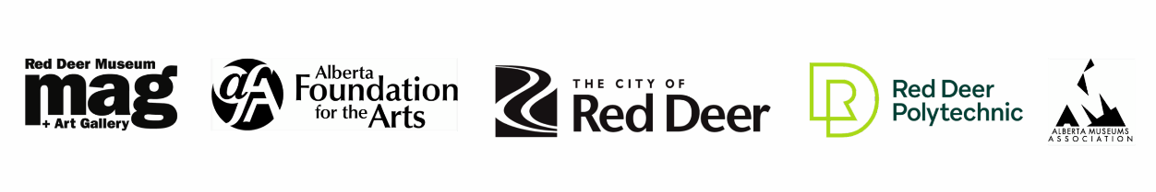
Under the Influence… Ian Cook: selected works of RDP Permanent Art Collection
September 6 – November 29, 2025
You are invited! In September, the MAG’s #FirstFridaysRedDeer evening will also offer a first-look at gallery 2 exhibit Under the Influence…
The Red Deer Polytechnic Permanent Art Collection was started by former Instructor Ian Cook, with the idea that students should see important works beyond photographic slides and visual aids. Ian helped to collect, donate and grow original works by Canadian and International masters. This exhibition will feature the works that were collected by or Under the Influence of Ian during his time at RDP.

Artribute Art School, 212 – 4836 50 Street, in the Old Courthouse. Treaty 6 & 7

Art in the Hallway, Northside Community Centre YMCA, 6391 76 Street

Curiosity Art & Framing, 5002 48 Street, Red Deer

Lacombe Memorial Centre 5214 – 50 Ave, Lacombe, AB

Lacombe Performing Arts Centre, 5227 Calgary Edmonton Trail, Lacombe, AB

Solorzano Spa Cafe & Wine Bar, 4631 50 Street, Red Deer

The Corridor Community Gallery, 4501 47A Ave, inside the Recreation Centre

The Majorie Wood Gallery, 6300 45Avenue Kerry Wood Nature Centre

The White Gallery, downstairs from Sunworks Living, 4913 50 Ave, Red Deer, AB

~~~








