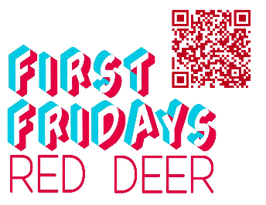
First Fridays Gallery Openings for Red Deer
February 6, 2026

Visit the interactive Gallery Guide with map and listings at:
https://www.reddeer.ca/recreation-and-culture/arts-and-culture/art-galleries/gallery-guide/

“The Canadian Landscape Abstract Paintings”
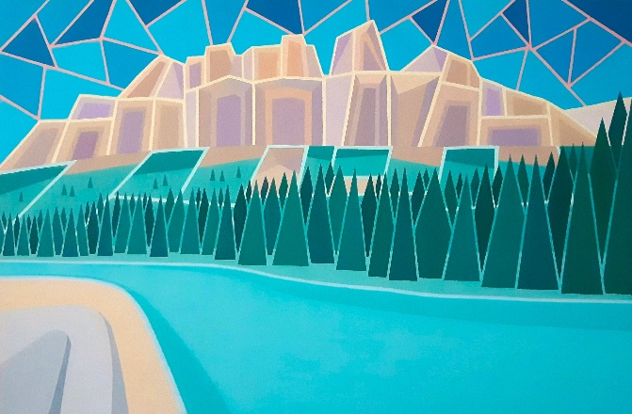
Artist: John Bladek
Medium: Acrylic on Canvas
Location: Kiwanis Public Art Gallery, Red Deer Public Library – Downtown Branch, 4818 49 Street
Exhibition Dates: December 2nd – February 8th, 2026
#FirstFridaysRedDeer
First Fridays Red Deer Opening: February 6th, 2026, from 5:30 to 7:30 pm.

Red Deer Arts Council and Red Deer Public Library are pleased to present, “The Canadian Landscape Abstract Paintings” artworks by John Bladek running from December 2nd until February 8th, 2026, in the Kiwanis Gallery.
Castle Mtn.
Acrylic on Canvas
John Bladek

This exhibition includes paintings of Canadian landscapes that John paints from where he lives and travels, from Nova Scotia to the Rocky Mountains and Alberta prairie scenes, as well as from Newfoundland to the Yukon and Northwest Territories. John finds inspiration from his appreciation of
the natural environment. Many of his paintings are of “iconic” Canadian scenes (Peggy’s Cove, Moraine Lake, etc.) and his hope is that people who view them will appreciate the fact that his interpretation is different and imaginative.

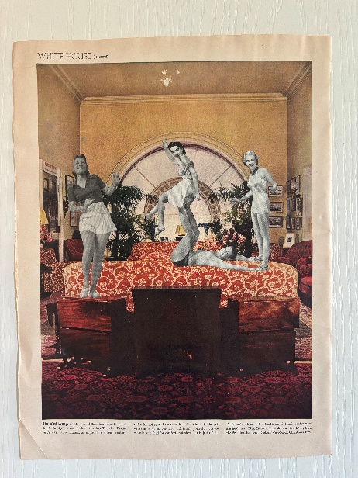
Februllage
Artist: Jaclyn Bell
Medium: Collage
The Red Deer Arts Council Community Gallery, Suite 6–4919 49 Street
Exhibition Dates: January 5th – February 20, 2026
#FirstFridaysRedDeer February 6th, 2026 from 5:00 – 7:00pm
Artist Jaclyn Bell will be in attendance

Red Deer Arts Council is pleased to present Februllage on display in the Community Gallery from January 5th until February 20th, 2026.

Februllage: Scavenging Through the Years showcases a collection of daily collages created in response to one-word prompts from the global February art challenge, Februllage. Built from found magazine images and guided by instinct, humor, and the joy of spontaneous creation, these works capture moments of curiosity and play across multiple years of participating in the global challenge.
Ghosts
Collage, Magazine
Jaclyn Bell
Viewers are invited to interact with the exhibit in their own way—by guessing the prompts behind each collage or using the provided guide to uncover them as they explore.

Jaclyn Bell is a self-taught collage artist, currently based in Edmonton, Alberta after calling Red Deer home for the past few years. Her love for collage began in high school, where she eagerly filled homework pages with magazine clippings. These early works weren’t about composition so much as the joyful obsession with leaving no white space behind. She even remembers making a collage for a friend’s homework, simply because she loved it that much.
Years later, while visiting an architecture museum in Montreal, Jaclyn stumbled upon a collage station. Bored by the rest of the museum, she sat down alone and created three pieces inspired by schoolboys and architectural forms.

Subject Matters: Red Deer Polytechnic 2D Art + Technology Student Photography Exhibition
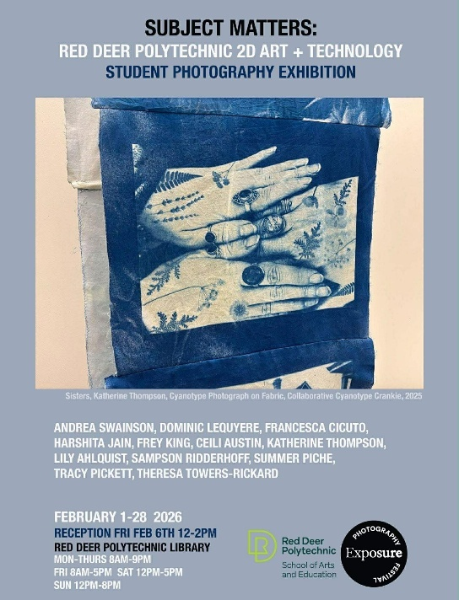
Artists: Andrea Swainson, Dominic LeQuyere, Francesca Cicuto, Harshita Jain, Frey King, Ceili Austin, Katherine Thompson, Lily Ahlquist, Sampson Ridderhoff, Summer Piche, Tracy Pickett, Theresa Towers-Rickard
Location: Red Deer Polytechnic Library
Exhibition Dates: February 1st – February 28, 2026
Location: Red Deer Polytechnic Library
Reception: February 6th 12-2pm
#FirstFridaysRedDeer
HOURS | Mon-Thu 8 AM-5 pm, sat 12-5 pm, Sun 12-8 PM ♿︎

Subject Matters brings together emerging student photographers exploring how images make meaning in a technological world. From observation to experimentation, these works reveal how attention and inquiry shape what we see and why it matters.
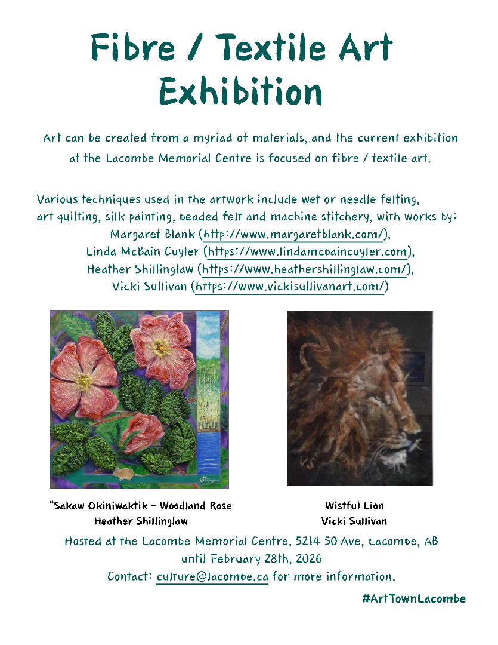

Fibre/Textile Art Exhibition
Artists: Margaret Blank, Linda McBain Cuyler, Heather Shillinglaw, Vicki Sullivan
Lacombe Memorial Centre 5214 – 50 Ave, Lacombe, AB
Exhibition Dates: Until February 28, 2026
#FirstFridaysRedDeer
Description: Art can be created from a myriad of materials, and the current exhibition at the Lacombe Memorial Centre is focused on fibre/ textile art.

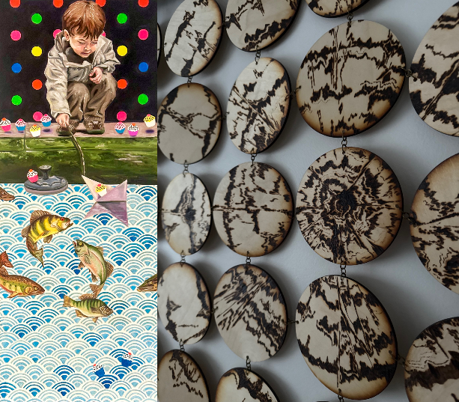
Process to Catharsis
Artists: Abigail Grenke, Andrea Swainson, Bailey Horton, Bethany Cyr, Daniel Corredor, Hannah Hicks, Theresa Towers Rickard
Medium: Mixed
Viewpoint Gallery, City of Red Deer Culture Services (Central Intermediate School,) 5205 48 Avenue
Dates: January 15, 2026- February 20, 2026
Reception: February 6th, 2026, 5-8pm
#FirstFridaysRedDeer
“The One Who Got Away”2022
Andrea Swainson
“The Giving Tree”, 2025
Bethany Cyr

Exhibition description:
In Process to Catharsis, seven artists come together to explore the complicated aspects of their lives. Each artist reconciles with deeply personal experiences, but we share common themes of grief, family, mental health, trauma, and burnout. Through a diverse set of practices including textiles, drawing, and sculptural work; every artist searches for catharsis, or at least, acceptance.

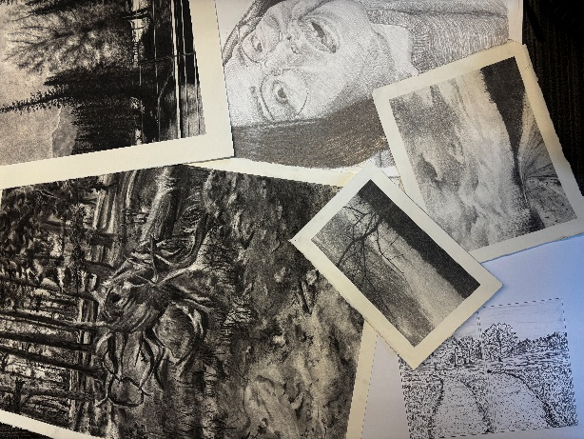
As We See It - Red Deer Polytechnic Second Year Drawing Student Exhibition
Artist(s): Ava Stang, Calleigh Nanooch, Charlee Craggs, Daniel Corredor, Femi Kharono, Fiona Nadon-Shields, Mya Brunner, Sam Ridderhof, Vipandeep Kaur

Media: Drawings
The Corridor Community Gallery, 4501 47A Ave, inside the Recreation Centre
Dates: January 15 – March 26, 2026
#FirstFridaysRedDeer
Exhibition description:
This selection of drawings were created by second year Visual Art Students at Red Deer Polytechnic. In their third semester of drawing the students continue to explore observational drawing, pushing their technical skills in portraiture, life drawing and expanding to an intense unit of en plein air study. Through these drawings you get a glimpse of this exploration.

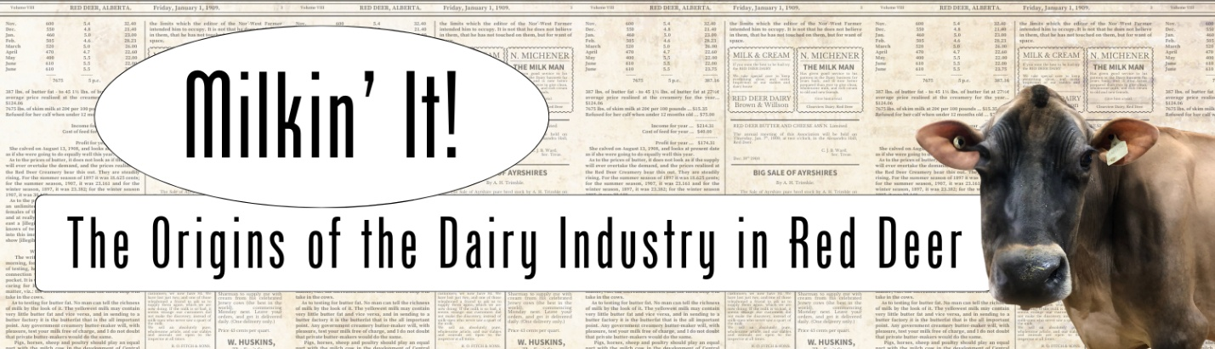
Milkin It!
Location: Red Deer Museum + Art Gallery (MAG), 4525 47A Avenue
Dates: December 13th – March 14, 2026
#FirstFridaysRedDeer
The MAG will be sharing the history of the dairy industry in Red Deer in a new exhibition. From the pioneer dairy farmers to the commercialization of dairying, to the rise of dairy cooperatives. The Dairy Industry in Red Deer is rich in history and has helped to sustain this community from it’s early beginnings as supplemental money and resources for mixed farmers to major Industry shipping around the world. This exhibition explores the early years of dairying in Red Deer.

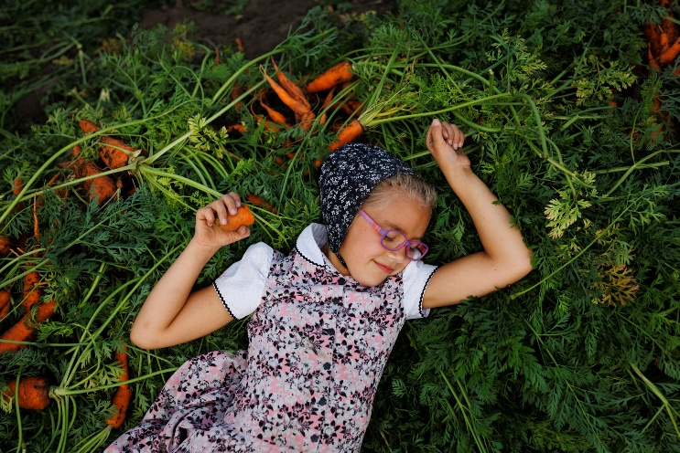
In the world, but not of it. Hutterite
Photography by Tim Smith
Location: Red Deer Museum + Art Gallery (MAG), 4525 47A Avenue
Artist: Tim Smith
Medium: Photography
Dates: December 6th – March 7th ,2026
#FirstFridaysRedDeer
For the past 15 years, Manitoba-based photographer Tim Smith has documented the daily lives of the Hutterites — a pacifist Anabaptist community with roots in the 16th-century Reformation. Living in colonies across western Canada and the northwestern United States, the Hutterites maintain their culture and traditions through communal living, self-sufficiency, and a steadfast separation from mainstream society. With over 45,000 members in approximately 500 colonies, they represent one of the most enduring and successful models of communal life today.
Tim Smith. Kira Wurtz lies atop a pile of freshly picked carrots… Deerboine Colony. 2010. Digital Photograph.

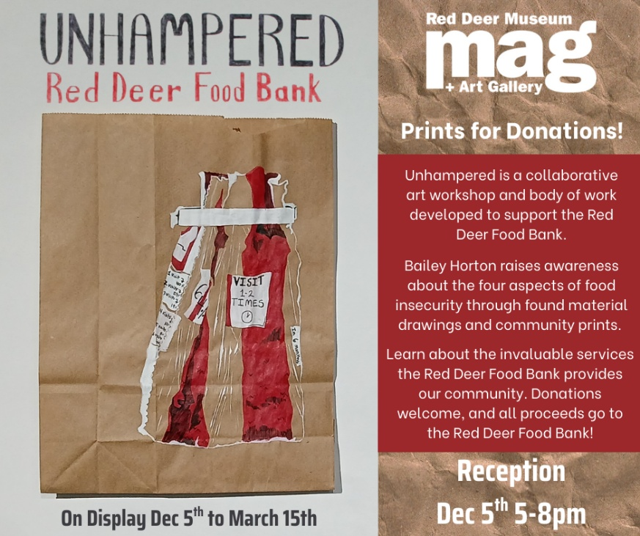
UNHAMPERED Red Deer Food Bank
Location: Red Deer Museum + Art Gallery (MAG), 4525 47A Avenue
Artist: Bailey Horton
Dates: December 5th until March 15th
#FirstFridaysRedDeer
Description: Bailey Horton is a multidisciplinary artist engaged in community advocacy. Their medium is often informed by their research, but primarily draws; with print, sculptural, and textile elements. Her latest project is Unhampered, which investigates food security in the Red Deer community.
The body of work explores imagery from their personal pantry, 2022 statistics from the Red Deer Food Bank, and found grocery material. Through paper bags, she considers the relationship between grocery shopping, in-store donations, and what composes a meal.
Unhampered is a collaborative art workshop and body of work developed to support the Red Deer Food Bank. Unhampered was developed in three interconnected stages: A visually researched body of work; a community carving workshop to foster discussion; and a live printing event. Through this experience, she explored how fine arts can foster communication and support for local issues.

"Winter’s Gift"
Location: Curiosity Art & Framing, 5002 48 Street, Red Deer
Artist(s):Various Brenda Garrett, Larry Reese, Lyn Anderson, Audrey Rits, Margaret Blank, and more!
Mediums: 2D and 3D
Dates: December 2nd - January 28th, 2026
#FirstFridaysRedDeer
Description: Enjoy the artistic beauty of winter with Curiosity Art & Framing latest exhibit, "Winter's Gift". Pieces in this exhibit are artists' different depictions of winter or holiday related scenes and objects. Stop by the gallery to see these unique and one of a kind pieces!

Artribute Art School, 212 – 4836 50 Street, in the Old Courthouse. Treaty 6 & 7

Art in the Hallway, Northside Community Centre YMCA, 6391 76 Street

Curiosity Art & Framing, 5002 48 Street, Red Deer

Lacombe Memorial Centre 5214 – 50 Ave, Lacombe, AB

Lacombe Performing Arts Centre, 5227 Calgary Edmonton Trail, Lacombe, AB

Solorzano Spa Cafe & Wine Bar, 4631 50 Street, Red Deer

The Corridor Community Gallery, 4501 47A Ave, inside the Recreation Centre

The Majorie Wood Gallery, 6300 45Avenue Kerry Wood Nature Centre

The White Gallery, downstairs from Sunworks Living, 4913 50 Ave, Red Deer, AB








