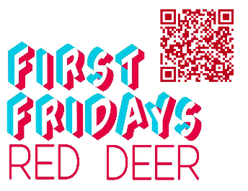
First Fridays Gallery Openings for Red Deer
April 10th, 2026

Visit the interactive Gallery Guide with map and listings at:
https://www.reddeer.ca/recreation-and-culture/arts-and-culture/art-galleries/gallery-guide/

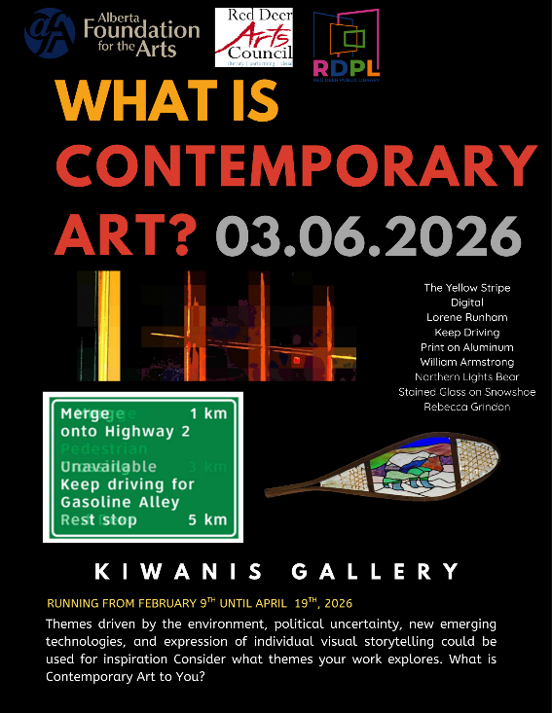
“What is Contemporary Art?”
Artists: Alison Forsberg, Bailey Horton, Carmen Therriault, Kerry Tronnes, Kristine Abramoff, Margaret Hall, Lorene Runham, Rebecca Grindon, Susan Delaney, Ula-Erin Chauvet and William Armstrong
Medium: Various 2D and 3D art
Location: Kiwanis Public Art Gallery, Red Deer Public Library – Downtown Branch, 4818 49 Street
Exhibition Dates: February 9th – April 10th, 2026
#FirstFridaysRedDeer
First Fridays Red Deer Opening: April 10th, 2026, from 5:30 to 7:30 pm.

Red Deer Arts Council and Red Deer Public Library are pleased to present, “What is Contemporary Art?” Contemporary art reflects current social, cultural, and political issues, engaging viewers in a dialogue about identity, technology, and global concerns. Contemporary is also artistic expressions created by living artists in today’s current times.
Themes driven by the environment, political uncertainty, new emerging technologies, and expression of individual visual storytelling could be used for inspiration Consider what themes your work explores. What is Contemporary Art to You?

Upon Return: Landscapes by Jessica Symons
Artist: Jessica Symons
Medium: Oil on Canvas
The Red Deer Arts Council Community Gallery, Suite 6–4919 49 Street
Exhibition Dates: February 23rd – April 10th, 2026
#FirstFridaysRedDeer April 10th, 2026, from 5:00 – 7:00pm
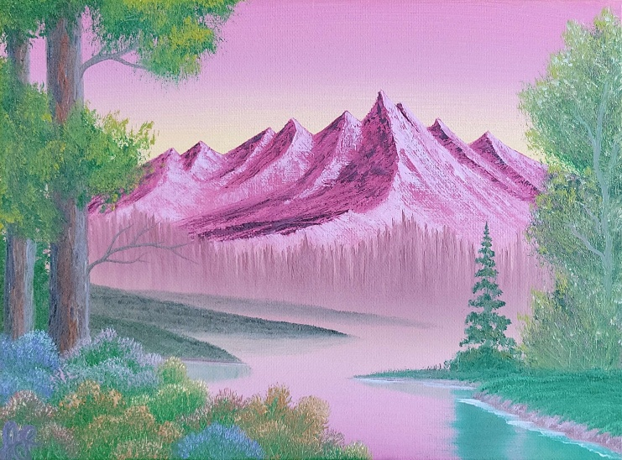

Red Deer Arts Council is pleased to present Upon Return: Landscapes by Jessica Symons on display in the Community Gallery.

Description: Born in Alberta and shaped by years spent exploring the breathtaking landscapes of the Canadian Rockies, Jessica returns with a powerful new body of work that bridges memory, distance, and rediscovery. After moving to the United States as a child, she carried the majesty of the Rockies with her only to find, upon her return as an adult, that while communities and perspectives had shifted, the land itself remained steadfast.
Evening Pyre III
Oil on Canvas
Jessica Symons
This exhibition is a moving tribute to Alberta’s enduring wilderness: a series of evocative paintings that serve as both love letters to the landscape and a deeply personal journey home.

Artist Statement: Jessica Symons is a self-taught artist whose practice is rooted in community, storytelling, and resistance. I create because art is one of the few places where complex emotions can coexist without needing permission. My work takes the form of landscapes, and while these scenes may initially appear quiet or apolitical, they are deeply tied to my values and lived experience. Land holds the weight of what has happened on it, from displacement and extraction to care and refuge.
Working primarily in an impressionistic and expressive style, I focus on mood, movement, and emotional truth rather than strict realism. Texture, layered colour, and visible brushwork allow the land to feel active and alive. I often begin intuitively, letting the work unfold through response and experimentation, mirroring how people relate to land through feeling before language and understanding.

Pop In Pop Up: Visual Art Student Exhibition
Artists: Red Deer Polytechnic Students
Medium: Various
Red Deer Polytechnic Learning Gallery & Studios,
Exhibition Dates: Tuesday April 21st 3pm-5pm

First Friday for Alberta Animals and Their Homes by the Red Deer Art Club
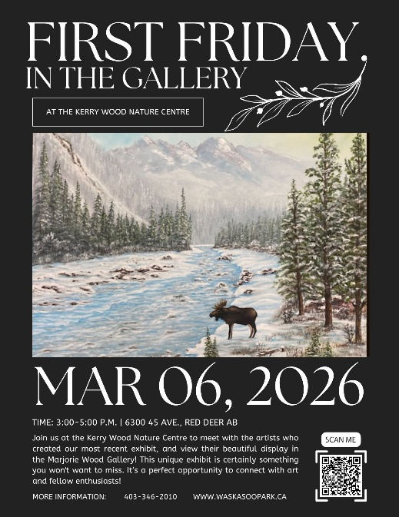
Artists: Red Deer Art Club
Medium: Various
The Majorie Wood Gallery, 6300 45Avenue Kerry Wood Nature Centre
Exhibition Dates: March 3 to April 28, 2026.
#FirstFridaysRedDeer
Join us at the Kerry Wood Nature Centre to meet with the artists who created our most recent exhibit and view their beautiful display in the Marjorie Wood Gallery!
"The Red Deer Art Club was founded in 1948 under the sponsorship of the University of Alberta, Department of Extension. The club has been in existence since then and has changed its membership and focus to adjust with the times. Now we are an all-inclusive club that meets once a week for artists of all abilities. We include individuals who work in many different mediums and at all levels. Each individual artist brings something special to the group and represents an artistic diversity. The club has regular shows, sales and workshop opportunities. Individual members participate in other art related activities as well. Join us on Facebook at Red Deer Art club."
All ages welcome.
Free.
Drop-in, come and go as you please.

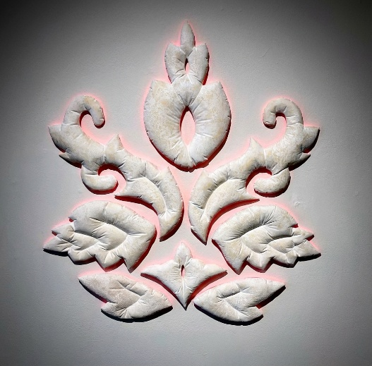
Anima Motrix v.2.0
Artists: Trudy Golley & Paul Leathers
Medium: Mixed
Viewpoint Gallery, City of Red Deer Culture Services (old Intermediate School,) 5205 48 Avenue
Dates: March 5, 2026- April 23, 2026
Reception: March 6th from 5-8pm
April 10th from 5-8pm
#FirstFridaysRedDeer

In A Paris Hotel Room
Ceramic, 2025
Trudy Golley

Exhibition description: Anima Motrix v.2.0 includes collaborative artworks in ceramics, metals, and mixed media. The artists construct forms that capture, transmit, obstruct and redirect light, and are interested in how such elements may be brought into conjunction with each other to create novel experiences for the viewer to encounter. Without depicting a specific event, object or place, they aim to capture and hold the viewer’s attention, trigger the imagination, and address notions of conceptual and intellectual illumination.

About the Artists:
Trudy Golley and Paul Leathers are internationally active Canadian artists with extensive experience in education, residencies, and workshops across North America, Europe, Asia, and Australia. Golley holds degrees from the Alberta College of Art, the University of Calgary (BFA), and the University of Tasmania (MFA), is an RCA and IAC member, and recently retired from teaching ceramics at Red Deer Polytechnic. Leathers studied at Sheridan College, NSCAD (BFA), and the University of Calgary (MFA), is an RCA member, and previously headed the Jewellery & Small Object Design program at the Kootenay School of the Arts. Both artists are major grant recipients and are represented in significant public and private collections internationally.

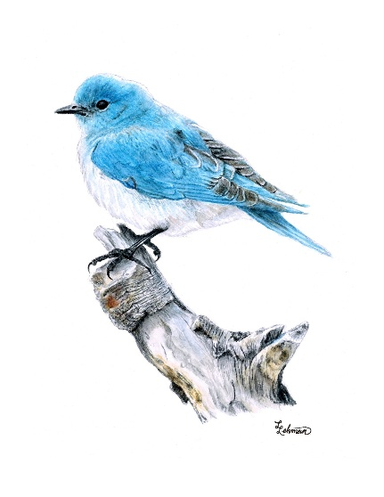
Fingerprints: the Wildlife of Alberta in Watercolour
Artist: Lewis Lehman
Media: watercolour
The Corridor Community Gallery, 4501 47A Ave, inside the Don Moore Recreation Centre
Dates: March 25 – May 28, 2026
#FirstFridaysRedDeer
Exhibition description: The pattern of spots on a Brown Trout’s scales, the way sunlight pierces through the eddies of a stream, the bits of wrinkled bark remaining on a weathered branch - all of these deserve a moment of contemplation. All preserve the fingerprints of the Creator. This simple watercolour exhibit hopes to inspire a sense of awe and appreciation for God’s design in this region of the world.
Blue Bird
Watercolour
Lewis Lehman

About the Artist:
Lewis Lehman is a realistic watercolour artist from Red Deer, Alberta. At just 16 years old, he draws inspiration from Robert Bateman, Carl Brenders and Dustin Van Wechel. Lewis’ love of creation, various outdoor activities and his wildlife biologist (and artist) father have influenced his artistic style and subject choice. Initially drawing inspiration from his father’s realistic wildlife drawings, Lewis continued to grow his skills from there. Lewis has won all three of the art contests in which he has participated, earning small money prizes and even a computer!

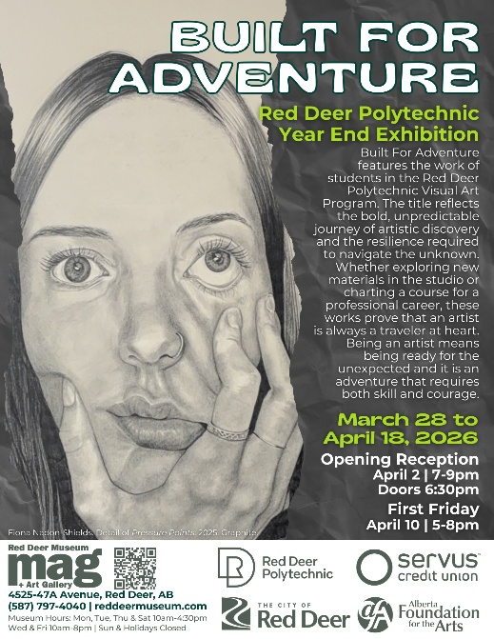
Built for Adventure: Red Deer Polytechnic Year End Exhibition
Location: Red Deer Museum + Art Gallery (MAG), 4525 47A Avenue
Artist: Red Deer Polytechnic Students
Medium: 2D and 3D artworks
Dates: March 28th – April 18th ,2026
Open Reception: April 2, 2026 | 7-9pm | Doors 6:30pm
#FirstFridaysRedDeer
Description: Featuring the work of students in the Red Deer Polytechnic (RDP) Visual Arts Program, Built for Adventure celebrates the bold, unpredictable journey of artistic discovery. This exhibition showcases emerging artists as they explore new materials, ideas, and creative directions. Proving that being an artist means embracing the unexpected with both skill and courage. Opening remarks, recognition, and awards begin at 7PM with a complementing reception courtesy of the RDP Cook Apprenticeship program, supported by Servus Credit Union, to follow.
Fiona Nadon-Shields.
Detail of Pressure Points. 2025. Graphite.

Description: Built For Adventure features the work of students in the Red Deer Polytechnic Visual Arts Program. The title reflects the bold, unpredictable journey of artistic discovery and the resilience required to navigate the unknown. Whether exploring new materials in the studio or charting a course for a professional career, these works prove that an artist is always a traveler at heart. Being an artist means being ready for the unexpected and it is an adventure that requires both skill and courage.

First "Second" Friday: Open Galleries
Date & Time: April 10, 2026 | 5-8pm
Description: This “Second” Friday is happening on the second week in April. Join us on April 10, from 5-8pm for snacks and refreshments and to check out the work of students in the Red Deer Polytechnic (RDP) Visual Arts Program. Built for Adventure celebrates the bold, unpredictable journey of artistic discovery. This exhibition showcases emerging artists as they explore new materials, ideas, and creative directions. Proving that being an artist means embracing the unexpected with both skill and courage.


Pigment of Your Imagination
Artists: Margaret Blank, Lyn Anderson, Marlene Kallstrom-Barritt, Wendy Meeres, Roger Neufeld, Brenda Garrett and many more!
Media: Various
Location: Curiosity Art and Framing 5002 48 St, Red Deer, AB
Dates: April 1st - May 26th, 2026
Description: Step into the Curiosity Art & Framing gallery and see our latest exhibit "Pigment of Your Imagination"! This exhibit features Monochromatic art pieces of various subjects. With one colour and shading see the fantastic pieces these local artists have created for your viewing. The exhibit is on display April 1st - May 26th, 2026.

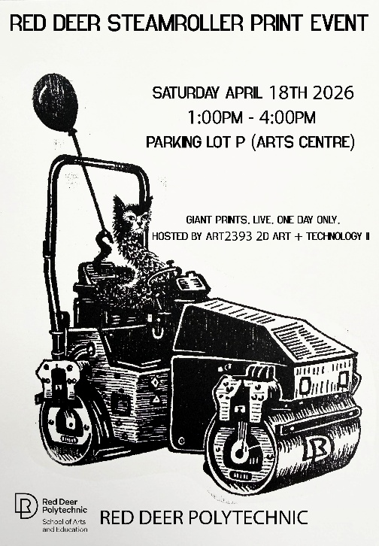
Red Deer Steamroller Print Event
Date: Saturday, April 18, 2026
Time: 1:00–4:00 PM
Location: Parking Lot P, Arts Centre – Red Deer Polytechnic
Description: Join Red Deer Polytechnic’s Visual Art students for an unforgettable large scale printmaking event outside the Arts Centre. Watch as hand carved woodcuts are inked and printed using a steamroller, transforming the parking lot into a print studio, hosted by students in ART 2393 2D Art + Technology II.
Free and open to the public.
Bring your own lawn chair.
Email Instructor marnie.blair@rdpolytech.ca for more information.

Artribute Art School, 212 – 4836 50 Street, in the Old Courthouse. Treaty 6 & 7

Art in the Hallway, Northside Community Centre YMCA, 6391 76 Street

Curiosity Art & Framing, 5002 48 Street, Red Deer

Lacombe Memorial Centre 5214 – 50 Ave, Lacombe, AB

Lacombe Performing Arts Centre, 5227 Calgary Edmonton Trail, Lacombe, AB

Solorzano Spa Cafe & Wine Bar, 4631 50 Street, Red Deer

The Corridor Community Gallery, 4501 47A Ave, inside the Recreation Centre

The Majorie Wood Gallery, 6300 45Avenue Kerry Wood Nature Centre

The White Gallery, downstairs from Sunworks Living, 4913 50 Ave, Red Deer, AB












